

**Solution Approach Document**

**Lead Management**

**Version 1.2**



SOLUTION APPROACH

For

Lead Management

By

Acidaes Solutions Pvt. Ltd.

Infospace, Tower 1, Ground Floor, Block B, Plot No. 2,

Sector 62, NOIDA - 201 309, UP, India;

Tel: (+91) 120 6784333; Fax: (+91) 120 6784334

Version: 1.2

Confidential and Proprietary

©Copyright 2011-2017, Acidaes Solutions Pvt. Ltd.

All Rights Reserved.

*The management team of Acidaes (the Company) has prepared this business document, and is being furnished to selected individuals within bank for the sole purpose of proposal evaluation, for sale of CRMNEXT and CRMNEXT services. This business document is confidential, and contains ideas, concepts, processes and other information that the Company considers proprietary. Readers are to treat the information contained herein as confidential and may not disseminate, copy or reproduce it in any form without the expressed written permission of the Company. ‘Acidaes’, ‘CRMNEXT, ‘Simplifying Technology’ and ‘smart. Easy. complete’ is applied trademarks of Acidaes Solutions Pvt. Ltd. All other trademarks are the property of their respective owners.*

**Revision History**

|  |  |  |  |  |  |
| --- | --- | --- | --- | --- | --- |
| **Sr. No.** | **Date** | **Version** | **Description** | **Author** | **Reviewer** |
|  | 29-03-2018 | v1.0 | Solution Approach | Mainakh Bhattacharjee | Shambhavi Nayan |
|  | 06-04-2018 | V1.1 | Solution Approach | Mainakh Bhattacharjee | Shambhavi Nayan |
|  | 26-05-2018 | V 1.1 | Updated Document | Mainakh Bhattacharjee | Fredrick Malela |
|  | 28-05-2018 | V 1.1 | Updated Document | Mainakh Bhattacharjee | Fredrick Malela |
|  | 29-05-2018 | V 1.2 | Updated Document | Mainakh Bhattacharjee | Fredrick Malela |

#### Table of Contents

1. Introduction 6

1.1 Abbreviations 6

1.2 Objective 7

1.3 Scope Of the Document 7

2. Roles 8

2.1. Bank Business ASIS Role Hierarchy 8

2.2. Proposed System Roles for the Sales Process Flow 9

2.3. Product Management 10

3. Process Map 17

3.1 Process Diagram 17

4. Sales Process Flow 18

4.1. Milestone and Status Code Mapping 18

4.2. Product Bundling Logic 18

4.3. Next Best Product 19

4.4. Sources and Channels 21

4.5. Identification & Creation 22

4.3.1. Identification 22

4.3.2. Customer Search 23

4.3.3. New Lead Creation 32

4.3.4. Lead to lead De-dupe 49

4.6. Qualification 56

4.4.1. Appointment Fixed 57

4.4.2. Not Interested 60

4.5. Fulfilment 62

4.5.1. Documents Collection 63

4.5.2. Follow UP 68

4.5.3. Send for Processing (Conditional Mandatory): 71

4.5.4. Lead Conversion 72

4.5.5. Lead Reject 73

5. Lead Sourcing 74

5.1 Website 74

5.2 Campaign Leads 77

5.3 Referrals 80

5.3.1 Referral Lead capture 81

5.3.2 Referral Lead processing 82

6. Process Setup 83

6.1 Status Codes 83

6.2 Views 84

6.3 Alerts Matrix 86

6.4 Customer communication 86

7. Assumptions 87

1. Introduction

This is an approach document for implementing I&M Bank’s Sales process comprising of Lead process using CRMNEXT for the segments such as Personal Banking and Premium Banking.

* 1. Abbreviations

Please find the list of abbreviations used in the document below:

|  |  |  |
| --- | --- | --- |
| **Sr.NO.** | **Abbreviation** | **Description** |
|  | PEB | Personal Banking |
|  | PRB | Premium Banking |
|  | CCE | Call Centre Executive |
|  | BM | Branch Manager |
|  | DSE | Direct Sales Executives |
|  | CSO | Customer Service Officer |
|  | RA | Relationship Analyst |
|  | RM | Relationship Manager |
|  | SRM | Senior Relationship Manager |
|  | AGM | Assistant General Manager |
|  | SAGM | Senior Assistant General Manager |
|  | DOB | Date of Birth |
|  | EOD | End of Day |
|  | NTB | New to Bank |
|  | ETB | Existing to Bank |
|  | CIF | Customer Information File – number uniquely identifying customer in Core Banking and LOS. |
|  | Customer Id | Customer Identifier for identifying customer uniquely in SFE tool. |

Table 1 - List Of Abbreviations

* 1. Objective

The objective is to implement the sales processes across all the product. This document describes lead origination from various channels for any Product, Lead handoff process to Finacle (Core Banking I&M).

1. The objective of is to implement the same process for capturing and processing Leads and Account Opening through Core Systems for segments such PEB and PRB.
2. This will ensure Sales life-cycle management for PEB and PRB segments. The PEB and PRB Sales process (Lead) flow will be same.

The processes will take input of Segment to differentiate the CSOs and RMs involved.

* 1. Scope Of the Document

This document covers the sales process for CSOs and DSEs.

The document will cover the following detail:

* + 1. Introduction
    2. Roles
    3. Process Map
    4. Sales Process Flow
    5. Lead Sourcing
    6. Process Setup
    7. Assumptions

1. Roles

This section describes the Administrative setup for I&M Bank.

* 1. Bank Business ASIS Role Hierarchy

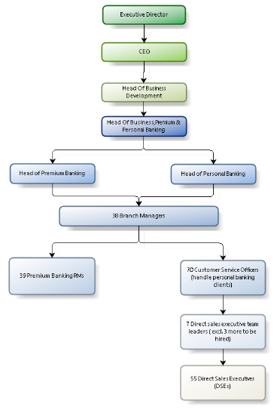

Figure 1-ASIS Bank Business Hierarchy

* 1. Proposed System Roles for the Sales Process Flow

|  |  |  |  |
| --- | --- | --- | --- |
| **Sr. No.** | **Abbreviation** | **Description** | **Access Rights** |
|  | PEB – DSE | Direct Sales Executive | 1. **Views:** View |
|  | PEB - CSO | Customer Service Officer | 1. **Leads**: Create, Modify, View 2. **Customer 360**: Modify, View 3. **Views:** View |
|  | PEB - BM | Personal Banking Branch Managers | * 1. Same as PEB – CSO for existing some accounts. |
|  | PEB - Head | Personal Banking Head | 1. **Leads**: View, Approval 2. **Customer 360**: View, Approval   **Views:** View |
|  | PRB – RM | Premium Banking Relationship Managers | 1. **Leads**: Create, Modify, View 2. **Customer 360**: Modify, View 3. **Views:** View |
|  | PRB – BM | Premium Banking Branch Managers | 1. Same as PRB – RM for existing some accounts. |
|  | PRB - Head | Head of Premium Banking | 1. **Leads**: View, Approval 2. **Customer 360**: View, Approval 3. **Views:** View |
|  | CAM-ST | Sales Team Campaign | 1. **Leads: Create,** Modify, View 2. **Customer 360:** View 3. **Views:** View |
|  | CAM-MH | Marketing Head | 1. **Leads: Create,** Modify, View 2. **Customer 360:** View 3. **Views:** View |
|  | CCE | Call Centre Executive | 1. **Leads: Create,** Modify, View 2. **Customer 360:** View 3. **Views:** View |
|  | Champion | Champion | * + - * 1. **Leads:** Modify, View         2. **Customer 360:** View         3. **Views:** View |

Table 2 - Proposed Roles

* 1. Product Management

Product management is an important organizational function. Products are mapped to

Team and Users that belong to a group or team.

The products will be created for each product category and then mapped to the team and users in the system.

* + 1. Product Mapping: Following mappings have been provided on lead management form:
  1. Business Category: The Business category is team or business group for which lead is being created. Business categories are mapped to product.
  2. Product Category: This is the first level product selection.
  3. Products - This will be the last selection. This will be actual branded product which is being sold to the customer.
     1. Product Format: Following is the description of Product category and Products. These product masters would need to be validated and last level branded product name would need to be provided.

|  |  |  |  |  |
| --- | --- | --- | --- | --- |
| **Sr. No** | **Product code** | **Business Category** | **Product Category** | **Product type** |
|  | 818 | Cards | Credit Card | I&M Visa Infinite Credit Card |
|  | 616 | Cards | Credit Card | Gold Visa Card |
|  |  | Cards | Credit Card | Gold Visa Tamarind |
|  | 717 | Cards | Credit Card | Classic Visa |
|  | 919 | Cards | Prepaid Card | Multicurrency Prepaid Card |
|  | 818 | Cards | Prepaid Card | I&M Visa Pre-Paid Travel |
|  | 819 | Cards | Prepaid Card | I&M Visa Pre-Paid Safari |
|  | 717 | Cards | Prepaid Card | I&M M-Pesa Pre-pay |
|  | TL101 | Assets | Secured Loan | Short Term Loan |
|  | TL102 | Assets | Secured Loan | Term Loans |
|  | IP101 | Assets | INSURANCE PREMIUM | IPF |
|  | OD101 | Assets | Secured Loan | Overdrafts |
|  | 901 | Assets | DIASPORA | DEAL FACILITATION |
|  | 902 | Assets | DIASPORA | DIASPORA INSURANCE |
|  | 1 | Assets | Trade Finance | LETTER OF GUARANTEE |
|  | 2 | Assets | Trade Finance | LETTER OF CREDIT |
|  | DB501 | Assets | Trade Finance | DEMAND BILLS OF EXCHANGE |
|  | DB502 | Assets | Trade Finance | DEMAND BILLS OF EXCHANGE |
|  | BDA | Assets | Trade Finance | BILLS DISCOUNTED ACCOUNT |
|  | BL101 | Assets | Trade Finance | BILLS DISCOUNTED |
|  | HP101 | Assets | HP Loan | HIRE PURCHASE LOAN |
|  | TD101 | Liabilities | Savings Deposit | Fixed Deposits |
|  | CD102 | Liabilities | Savings Deposit | Call Deposits |
|  | RD102 | Liabilities | Savings Deposit | Flexi Deposit Builder |
|  | SB101 | Liabilities | Savings Deposit | Young Savers |
|  | SB102 | Liabilities | Savings Deposit | Online Savers |
|  | RD101 | Liabilities | Savings Deposit | My Goalz Account |
|  | PT101 | Liabilities | Savings Account | Personal Sapphire |
|  | PT108 | Liabilities | Savings Account | Personal Malaika |
|  | PT102 | Liabilities | Savings Account | Personal Bahati |
|  | PT106 | Liabilities | Savings Account | Personal Tayari |
|  | BT101 | Liabilities | Business Transaction | BUSINESS SAPPHIRE |
|  | BT102 | Liabilities | Business Transaction | BUSINESS BIASHARA |
|  | BT109 | Liabilities | Business Transaction | ALPHA |
|  | BT110 | Liabilities | Business Transaction | SAVANNAH |
|  | BT114 | Liabilities | Business Transaction | CHAMA ACCOUNT |
|  | FC101 | Liabilities | Business Transaction | BUSINESS SAPPHIRE FCY |
|  | FC102 | Liabilities | Business Transaction | BUSINESS SAPPHIRE FCY W/O CHQ BK |
|  | MG101 | Liabilities | Business Transaction | MARGIN ACCOUNTS |
|  | 903 | Liabilities | DIASPORA | DIASPORA ONLINE PAYMENT |
|  | BT111 | Liabilities | NGO | NOBLE ACCOUNT |
|  | 27 | Insurance | Bancassurance | CROP INSURANCE |
|  | 63 | Insurance | Bancassurance | CONTRACTORS ALL RISKS |
|  | 82 | Insurance | Bancassurance | MOTOR TRADE |
|  | 83 | Insurance | Bancassurance | MOTOR CYCLE |
|  | 101 | Insurance | Bancassurance | GOLFERS INSURANCE |
|  | 102 | Insurance | Bancassurance | CREDIT CARDS |
|  | 103 | Insurance | Bancassurance | PROPERTY TERRORISM |
|  | 11 | Insurance | Bancassurance | BURGLARY |
|  | 111 | Insurance | Bancassurance | DIRECTORS & OFFICERS LIABILITY |
|  | 115 | Insurance | Bancassurance | PUBLIC LIABILITY INSURANCE |
|  | 114 | Insurance | Bancassurance | WORKMENS COMPENSATION ACT |
|  | 117 | Insurance | Bancassurance | WIBA PLUS |
|  | 113 | Insurance | Bancassurance | EMPLOYERS LIABILITY INSURANCE |
|  | 118 | Insurance | Bancassurance | CONTRACTUAL LEGAL LIABILITY |
|  | 119 | Insurance | Bancassurance | PROFESSIONAL INDEMNITY |
|  | 112 | Insurance | Bancassurance | ALL RISKS |
|  | 1201 | Insurance | Bancassurance | MARINE OPEN COVER |
|  | 121 | Insurance | Bancassurance | MARINE HULL |
|  | 123 | Insurance | Bancassurance | MARINE CARGO |
|  | 124 | Insurance | Bancassurance | CARRIERS LIABILITY |
|  | 43 | Insurance | Bancassurance | INDUSTRIAL ALL RISKS |
|  | 131 | Insurance | Bancassurance | MEDICAL INDIVIDUALS |
|  | 1312 | Insurance | Bancassurance | AFYA IMARA |
|  | 13122 | Insurance | Bancassurance | AFYA IMARA COUNTY |
|  | 14 | Insurance | Bancassurance | MONEY |
|  | 15 | Insurance | Bancassurance | FIDELITY GUARANTEE |
|  | 153 | Insurance | Bancassurance | PERSONAL ACCIDENT |
|  | 16 | Insurance | Bancassurance | GROUP PERSONAL ACCIDENT |
|  | 18 | Insurance | Bancassurance | GOODS IN TRANSIT |
|  | 19 | Insurance | Bancassurance | LIVESTOCK |
|  | 22 | Insurance | Bancassurance | CUSTOMS BONDS |
|  | 24 | Insurance | Bancassurance | CREDIT LIFE POLICY |
|  | 25 | Insurance | Bancassurance | TRAVEL |
|  | 251 | Insurance | Bancassurance | AMREF |
|  | 26 | Insurance | Bancassurance | MORTGAGE PROTECTION POLICY-DAYS |
|  | 261 | Insurance | Bancassurance | MORTGAGE PROTECTION POLICY-MONTHS |
|  | 28 | Insurance | Bancassurance | MEDICAL CORPORATES |
|  | 501 | Insurance | Bancassurance | ELECTRONIC EQUIPMENT |
|  | 31 | Insurance | Bancassurance | GREEN HOUSE INSURANCE |
|  | 33 | Insurance | Bancassurance | PETS |
|  | 34 | Insurance | Bancassurance | GROUP LIFE |
|  | 35 | Insurance | Bancassurance | POLITICAL VIOLENCE & TERRORISM INSURANCE |
|  | 37 | Insurance | Bancassurance | PLATE GLASS |
|  | 38 | Insurance | Bancassurance | PERFORMANCE BOND |
|  | 39 | Insurance | Bancassurance | GUARANTEE BONDS |
|  | 41 | Insurance | Bancassurance | FIRE & PERILS |
|  | 411 | Insurance | Bancassurance | DOMESTIC PACKAGE |
|  | 42 | Insurance | Bancassurance | FIRE CONSEQUENTIAL LOSS |
|  | 421 | Insurance | Bancassurance | J CARE CLASSIC |
|  | 422 | Insurance | Bancassurance | J CARE PREMIER |
|  | 423 | Insurance | Bancassurance | J CARE ADVANCED |
|  | 424 | Insurance | Bancassurance | J CARE EXECUTIVE |
|  | 425 | Insurance | Bancassurance | J CARE ROYAL |
|  | 12 | Insurance | Bancassurance | ALL RISKS |
|  | 45 | Insurance | Bancassurance | BUSINESS INTERUPTION |
|  | 61 | Insurance | Bancassurance | MACHINERY BREAKDOWN |
|  | 46 | Insurance | Bancassurance | SMEs BUSINESS COMBINED |
|  | 461 | Insurance | Bancassurance | BID BOND |
|  | 462 | Insurance | Bancassurance | BANKER'S BLANKET |
|  | 463 | Insurance | Bancassurance | WORK PERMIT BOND |
|  | 471 | Insurance | Bancassurance | INDIVIDUAL PENSION |
|  | 472 | Insurance | Bancassurance | GROUP PENSION |
|  | 481 | Insurance | Bancassurance | EDUCATION POLICY |
|  | 483 | Insurance | Bancassurance | ENDOWMENT POLICY |
|  | 484 | Insurance | Bancassurance | KEYMAN INSURANCE |
|  | 485 | Insurance | Bancassurance | UNIT LINKED |
|  | 241 | Insurance | Bancassurance | FAMILY LIFE POLICY |
|  | 482 | Insurance | Bancassurance | FUNERAL EXPENSES POLICY |
|  | 51 | Insurance | Bancassurance | MOTOR PSV |
|  | 57 | Insurance | Bancassurance | MOTOR COMMERCIAL SCHOOL BUS |
|  | 64 | Insurance | Bancassurance | MACHINERY BREAKDOWN CONSEQUENTIAL LOSS |
|  | 65 | Insurance | Bancassurance | ERECTION ALL RISKS |
|  | 66 | Insurance | Bancassurance | CONTRACTORS PLANT AND MACHINERY |
|  | 701 | Insurance | Bancassurance | MOTOR PRIVATE |
|  | 703 | Insurance | Bancassurance | MOTOR COMMERCIAL-OWN GOODS |
|  | 704 | Insurance | Bancassurance | MOTOR COMMERCIAL-GENERAL CARTAGE |
|  | 705 | Insurance | Bancassurance | MOTOR COMMERCIAL-TANKER |
|  | 81 | Insurance | Bancassurance | MOTOR COMMERCIAL-SPECIAL VEHICLES |
|  | 801 | Insurance | Bancassurance | AVIATION HULL |
|  | 802 | Insurance | Bancassurance | AVIATION |
|  | 900 | Insurance | Bancassurance | SANLAM LAST EXP |

Table 3 – Products Management

1. Process Map
   1. Process Diagram

The designed process flow has been depicted below and the detailed description of the

Source-wise flow has been provided below the process diagram:

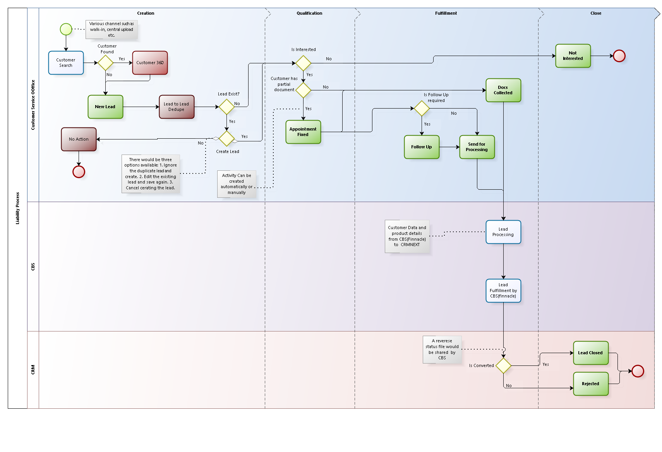

Figure 2 - Process Flow

1. Sales Process Flow
   1. Milestone and Status Code Mapping

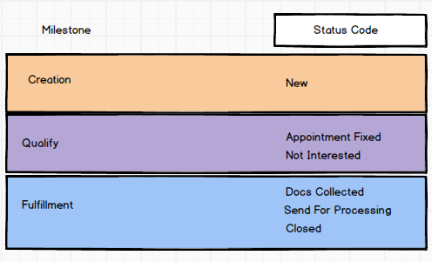

Figure 3 - Milestones

* 1. Product Bundling Logic

1. The purpose of product bundling is to display the products that are bundled in one product bundled category for a Customer be it a NTB or ETB.
2. Products in the bundle while creating a Lead will be displayed on the basis of the Product Category.
3. Just like the product category, a product bundle eg: “Young Professional” will be mapped to the product category and the list of the products will be there on the lead creation page.

Below is the Product bundle structure:

| **Sr. No** | **Business Category** | **Product Category** | **Product type** |
| --- | --- | --- | --- |
|  | Premium Select Bundle | Credit Card | I&M Visa Infinite Credit Card |
|  | Premium Select Bundle | Bancassurance | Bancassurance |
|  | Young Professionals Bundle | Savings Deposit | MyGoalz Savings Account |
|  | Young Professionals Bundle | Bancassurance | Bancassurance |
|  | Premium Esteem Bundle | Credit Card | Gold VISA Card |
|  | Premium Esteem Bundle | Bancassurance | Bancassurance |
|  | Business Banking Bundle | Transaction Account | Sapphire Business |

Table 4 - Product Bundle Structure

The product structure mapping will be as displayed below:

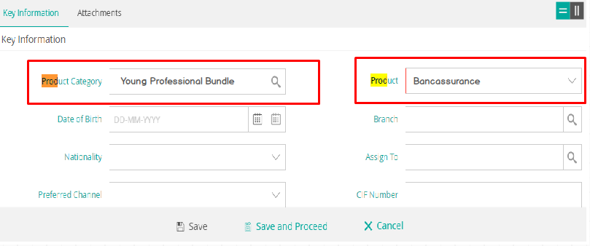

Figure 4 - Product Bundle Structure

1. Each product selected on the basis of the product bundle will be treated as an Individual Lead and will be processed individually.
2. Once the leads created on the same product bundle with similar demographic details and the first lead that will be processed through will Create/Update the Customer. Based on that the rest of the leads with the same demographic details will be stamped with the Cust ID of the first closed lead.
   1. Next Best Product

The next best products will be calculated on the basis of different segments, lifestyle, gender, marital status and classification.

Based on the below table the next best product for different segments will be displayed:

|  |  |  |  |  |  |  |  |
| --- | --- | --- | --- | --- | --- | --- | --- |
| **Segment** | **Income** | **Life Style** | **Gender** | **Marital Status** | **Classification**  **(2 combined factors)** | **Profession or Occupation** | **Distribution Channel** |
| BB | N/N/A | N/A | N/A | N/A | 1. Employees >10<100 2. Turnover >25M<500M 3. Bal Sheet >25M<500M | Specific as defined below Not applicable  Noted | N/A |
|  | | | | | | | |
| PrB | 1. >Kes 1M | Income dictates lifestyle Not applicable  Noted | 1. F 2. M 3. Minor | 1. Married 2. Widow/ed 3. Divorced 4. Separated 5. Other | 1. Employees <10 2. Turnover <25M 3. Bal Sheet <25M | Specific as defined below not applicable  Noted | N/A |
|  | | | | | | | |
| PB | 1. >Kes 75K < Kes 100K 2. >Kes 100K < Kes 200K 3. >Kes 200K <Kes 300K | Income dictates lifestyle Not applicable  Noted | 1. F 2. M 3. Minor | 1. Married 2. Window/ed 3. Divorced 4. Separated 5. Other | 1. Employees <10 2. Turnover <25M 3. Bal Sheet <25M | Specific as defined below Not applicable  Noted | N/A |
|  | | | | | | | |

|  |  |  |
| --- | --- | --- |
| **Business Banking Segment** | | |
|  | | |
| Income | N/A | N/A |
|  | | |
| **Premium Banking Segment** | | |
| Age | +65 years (Select) &  35 – 50 years (Esteem) | All available product mix on offer in the  segment |
|  | | |
| Income | >Kes 1M (Select) &  Kes 300K – 1M (Esteem) | All available product mix on offer in the  segment |
|  | | |
| Life Style | Income dictates lifestyle | All available product mix on offer in the  segment |
|  | | |
| Gender | Female | All available product mix on offer in the  segment subject to specific gender target |
| Male |
| Minor |
|  | | |
| Marital Status | Married | All available product mix on offer in the  segment |
| Widow/widowed |
| Divorced |
| Separated |
| Other |
| **Personal Banking Segment** | | |
| Age | N/A | All available product mix on offer in the  segment |
|  | | |
| Income | >Kes 75K < Kes 300K | All available product mix on offer in the  segment |
|  | | |
| Life Style | Income dictates lifestyle | All available product mix on offer in the  segment |
|  | | |
| Gender | Female | All available product mix on offer in the  segment subject to specific gender target |
| Male |
| Minor |
|  | | |
| Marital Status | Married | All available product mix on offer in the  segment |
| Widow/widowed |
| Divorced |
| Separated |
| Other |
|  | | |

* 1. Sources and Channels

Leads will be generated through various channels. The channels through which leads will be generated are given below:

* + 1. Branch walk-ins/Direct Sales Channel
  1. ***Branch Walk-in*:** Customer walk-in directly in Branch for any of the I&M products offering
  2. ***Sales Executive*:** Customer interacts with Direct Sales Executive with an interest in any of I&M products offering.
  3. Identification & Creation

The Leads will be generated in CRM from various sources and channels. The most general lead management flow for leads is the leads generated through branch walk-ins and the same is depicted and described in detail below:

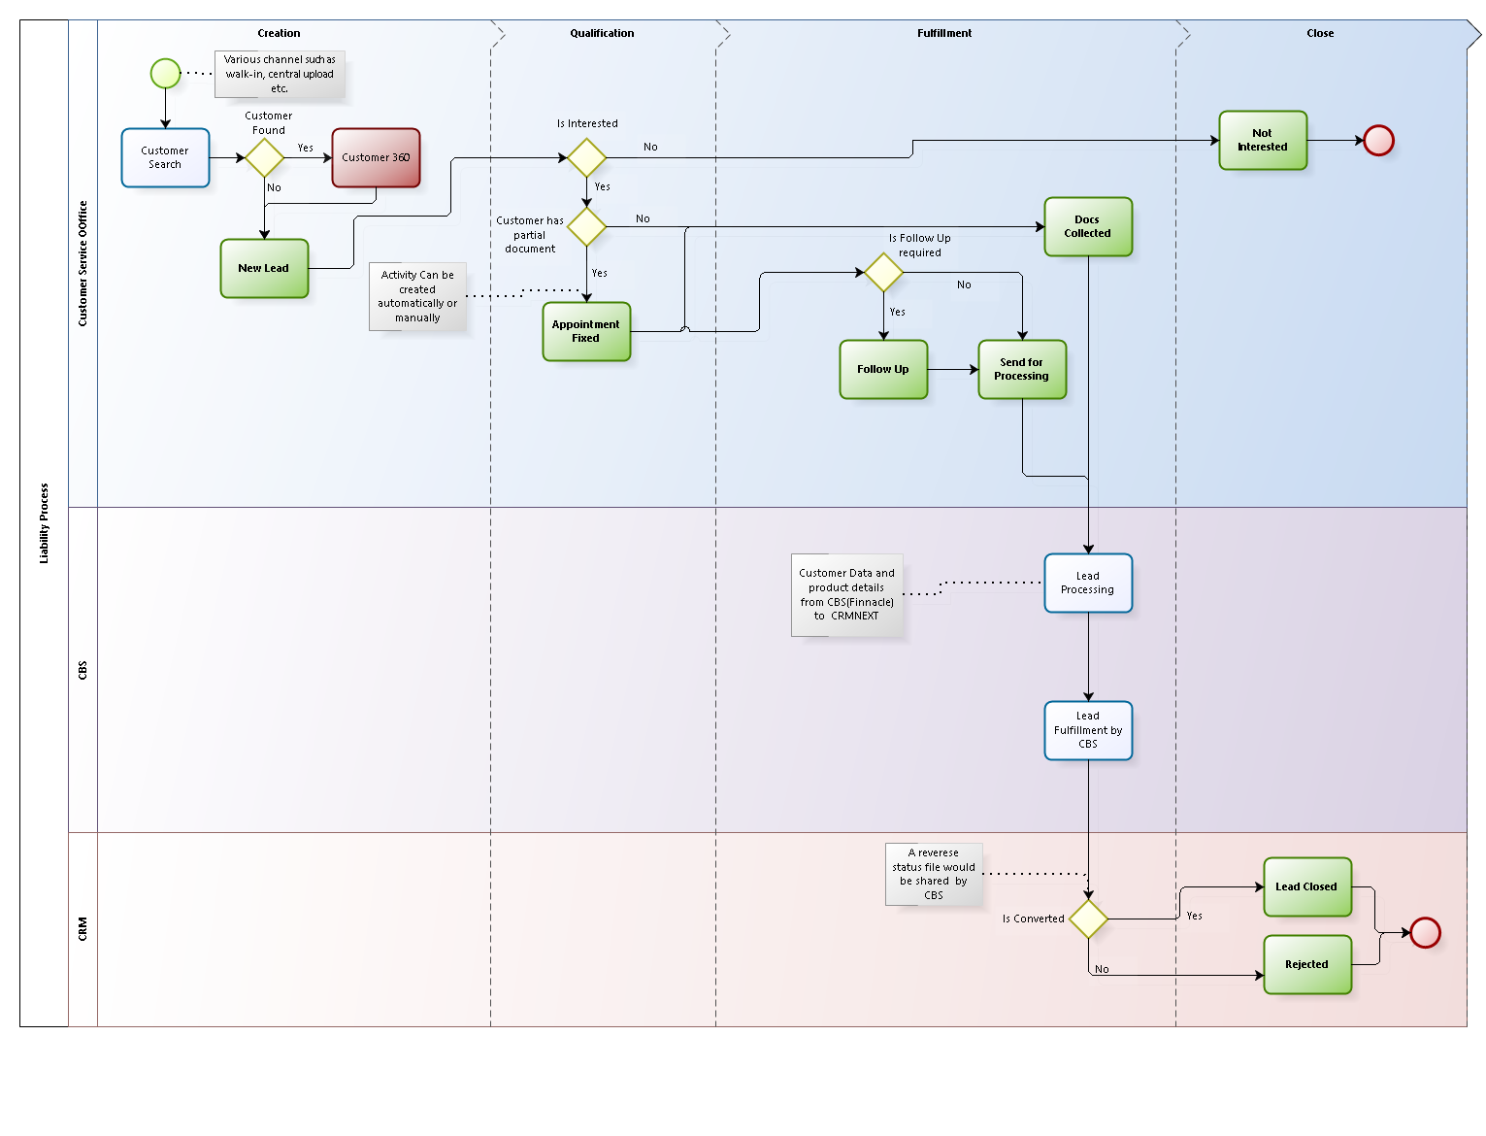

Figure 5 - Process Flow

Note Box:

Screenshots provided in this document are only for reference purpose and actual screens may defer from the Screenshots displayed in the document.

.



### Identification

Lead Identification covers the creation of Lead from various sources through different channels. The sources are listed below and please refer section Lead Sources for more details.

* + 1. Website (Online Leads generated at I&M Bank’s website)
    2. Campaigns
    3. Walk ins
    4. Referrals

The methods through which Leads will be generated where the sources are as listed above are:

* + 1. CRMNEXT UI( Manually creating leads in the system- Explained in the below section)
    2. CRMNEXT web service(refer to the Lead sourcing section for further details)
    3. Batch jobs (refer to the Lead sourcing section for further details)
    4. CSV file (Lead Import, manual import by the CRMNEXT user- (refer the Lead sourcing section for further details))

The below section describes the process of creating the lead using CRMNEXT UI. The user would create the leads in CRMNEXT manually.

### Customer Search

* + 1. Navigation: The user can navigate to the customer screen by clicking on the Customer tab.
    2. Manual Search: CRM system will provide a “Customer Search” through which the CRMNEXT user can perform an Advance Customer Search. Refer the screenshot below:

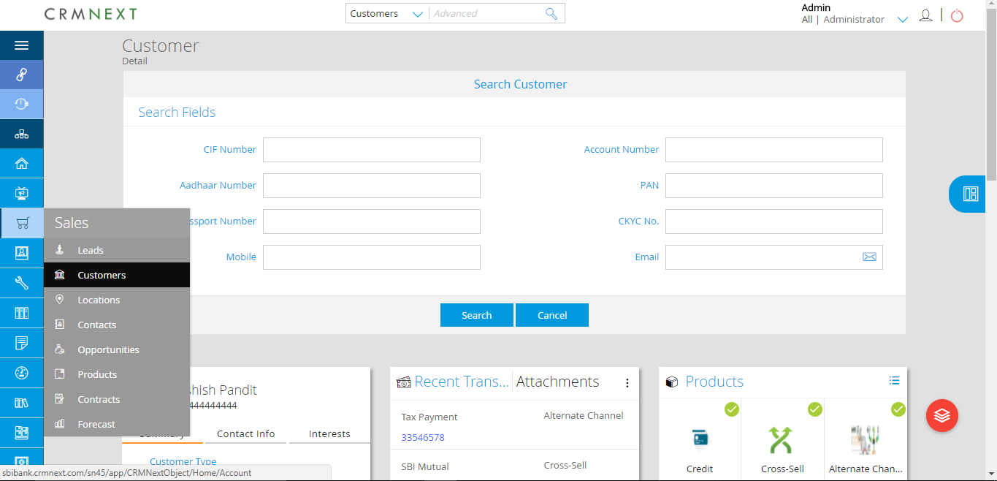

Figure 6 - Customer Advance Search

* + 1. Accessibility: The search functionality will be provided to all the roles mentioned under Role section.
    2. Search Parameters : The search parameter with the details are mentioned below:

| **Search Parameter** | **Type** | **Role** | **Search Type** |
| --- | --- | --- | --- |
| Segment | Dropdown | All | Exact |
| Cuts ID/CIF/Prospect Number | Text | All | Exact |
| Mobile Number | Numeric | All | Exact |
| Customer Name | Text | All | Starting with entered Text |
| Account Number | Text | All | Exact |
| Group Name | Text | All | Starting with entered Text |
| P.O. Box Number | Text | All | Exact |
| Postal Code | Text | All | Exact |
| Email | Email | All | Exact |

Table 5 - Customer Search Field

* + 1. Output : There will be 2 outcome based on the search done in CRM application:

Outcome 1: Customer Found- Now for this outcome there will be 2 scenarios

Single Customer –

Screen- When a single /unique customer is found then the application will open customer 360* (refer the screenshot below).

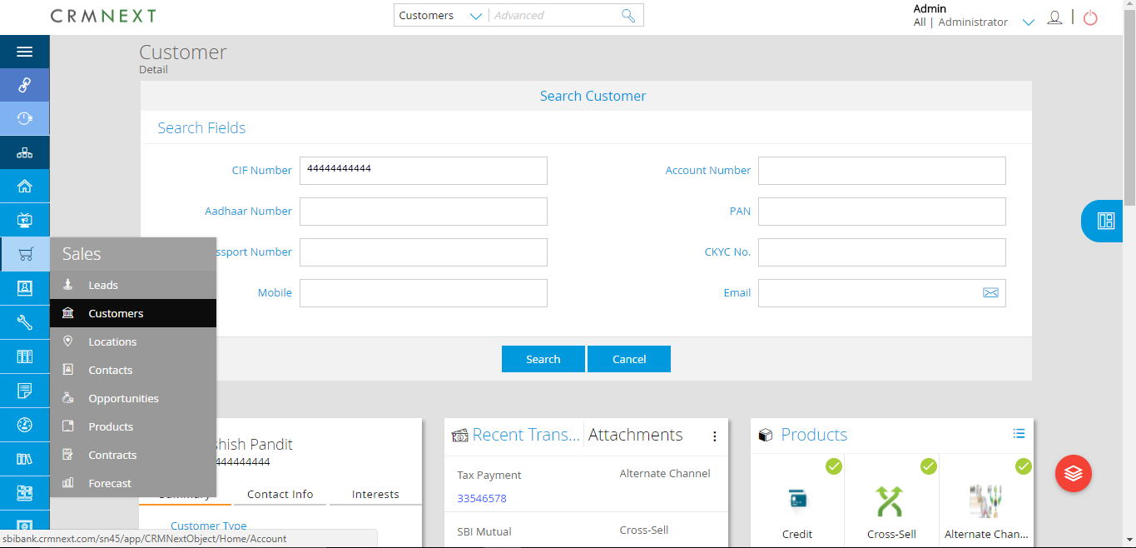

Figure 7 - Customer Advance Search

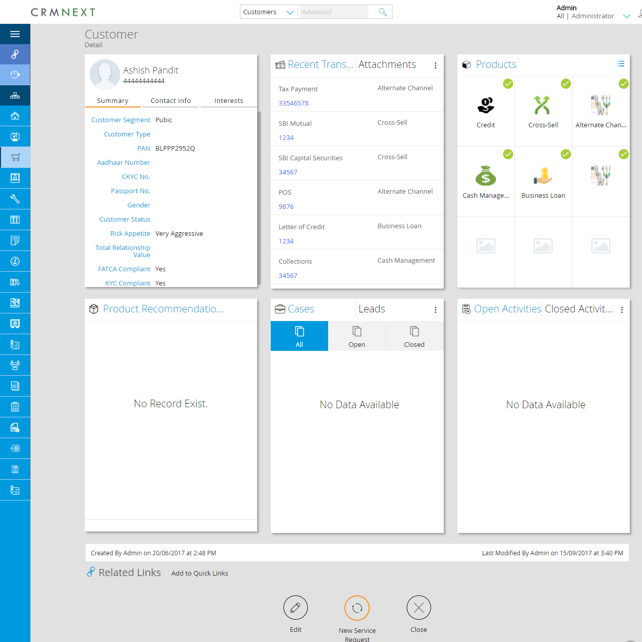

Figure 8 - Customer 360

Further Process (Lead Creation): A new Lead will be created from the Customer 360 using the “New Lead” icon. Such leads would get tagged against that particular customer

More than one Customer – When the application finds more than one customer in the database based on the search parameters , the following would happen:

Listing Screen – The listing screen, with the customer data as shown in the figure below would appear.

Customer 360* navigation: User can navigate to particular customer 360* screen by clicking on the particular Customer Name as provided in the listing view.

Further Process (Lead Creation): A new lead will be created from the Customer 360 using the “New Lead” icon. Such leads would get tagged against that particular customer.



Figure 9 - Customer Search

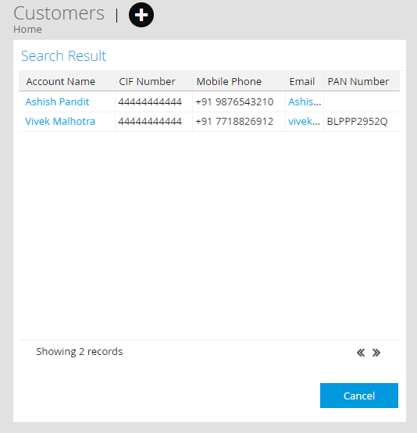

Figure 10 - Customer Search

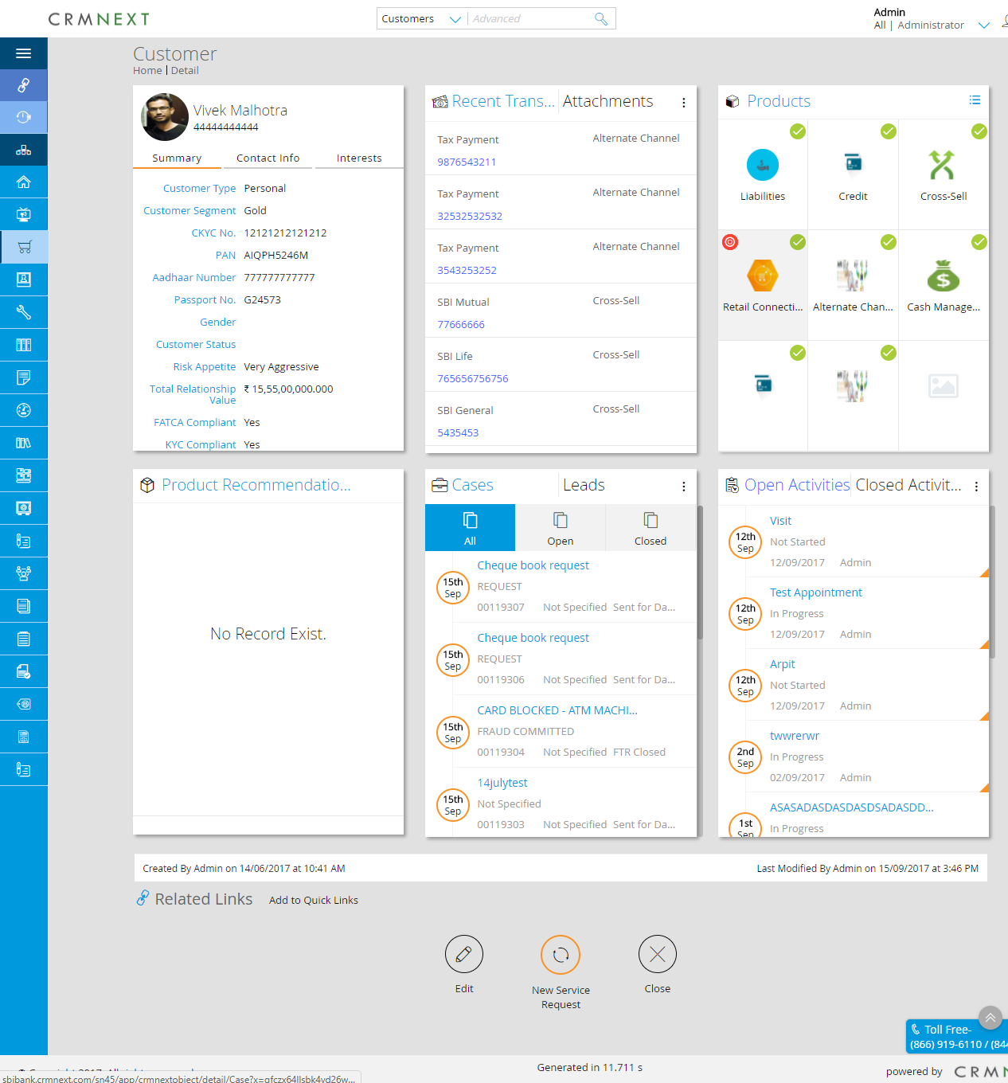

Figure 11 - Customer 360 sample

Outcome 2: Customer Not Found- Now for this outcome the scenarios are:

1. No Customer found in CRM database & Core banking system (not a bank customer)

Screen: When no customer found basis the given parameter, the error screen would appear. (Refer the screenshot below).



Figure 12 - Customer Search

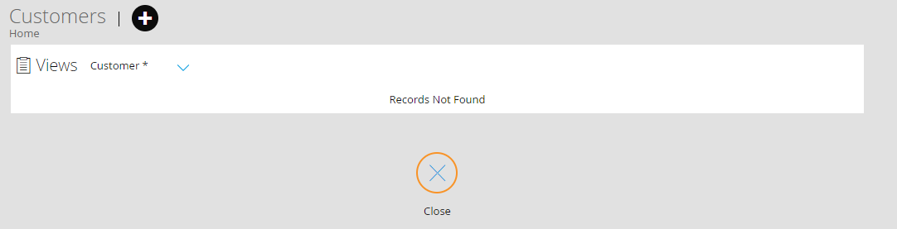

Figure 13 - Customer Search

1. Further Process (Lead Creation)**:** A lead will be created using the relevant quick link for Lead creation. Such leads would not get tagged against any customer. This lead will be created as standalone lead in the system.

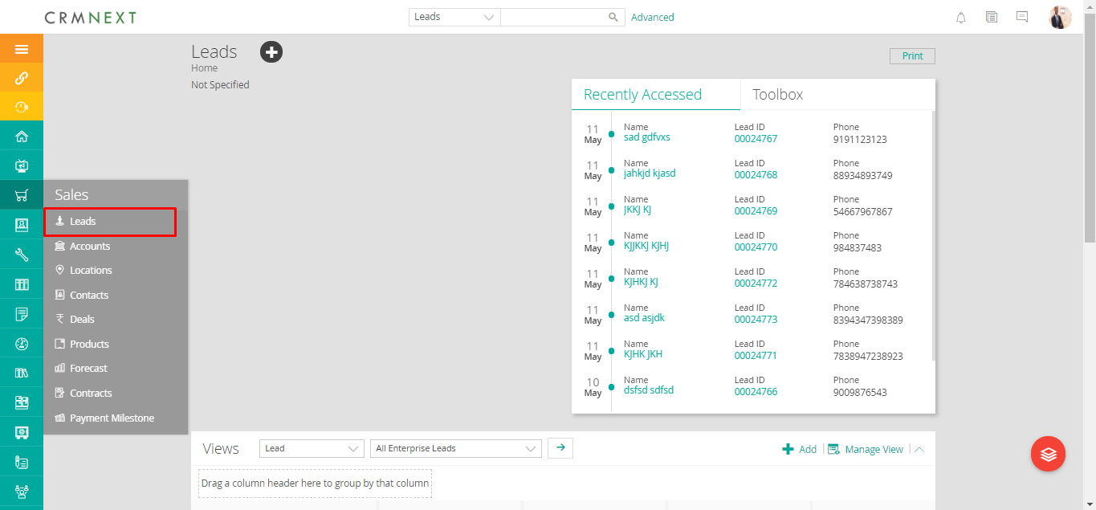

Figure 14 - Independent link

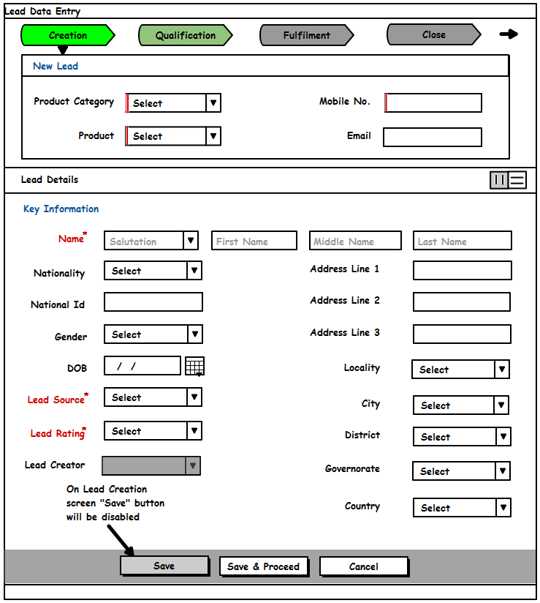

Figure 16 - Lead Creation

Following table describes all the scenarios described above:

| **Sr. No.** | **Start**  **Condition** | **Action** | **Action Type** | **Process** | **End Result** |
| --- | --- | --- | --- | --- | --- |
| 1 | Customer found in customer search | Lead Creation | Manual | The user creates the Lead across the customer 360 page. | New Lead created & tagged to the existing customer |
| 3 | Not a bank Customer (CIF /Cust ID doesn’t exist) | Lead Creation | Manual | The user creates a standalone lead in the system using quick link | Standalone Lead is created and customer name & other details are inputted manually |

Table 6 - Customer Search

### New Lead Creation

Leads will be created for the following types of customers:

* + 1. **New to Bank (NTB):** If the Customer is New to Bank, a standalone Lead will be created in the system.

**Lead Creation for NTB**

* 1. **Creator:** Lead will be created by the following roles :

1. Customer Service Officer (CSO) BMs/RMs? And what about Asset Finance, Bancassurance including CIB RMs? Marketing may as well initiate creation if need be. I think each source should be able to create a lead and assign.
2. Direct Sales Executive (DSE)
3. Call Center Executive (CCE)
   1. **Lead Data entry:**
4. Basic Description: Lead will be created with basic/mandatory information as a part of ‘Quick Data Entry (QDE), for various products like:
   * + 1. Retail Deposit Products
       2. Credit Card Products
       3. Prepaid Products
       4. Loans (Assets)
5. Field Description: The field will be further divided into 2 kinds of categories
   * 1. *Fields:* Below table shows the fields that will be auto populated on the Lead new edit screen for NTB:

|  |  |  |  |  |  |  |  |  |  |
| --- | --- | --- | --- | --- | --- | --- | --- | --- | --- |
| Sr. No. | Field | Field Type | Field length | Field Validation | Editable | Lookup | Dependent on | Mandatory | Auto Populate |
|  | Salutation | Picker | NA | Values as: 1. Mr. 2. Mrs. 3. Ms. 4. Mstr. 5. Dr. 6. Eng. 7. Hon. 8. Prof. | Yes | Yes | No | Yes | No |
|  | First Name | Alphabet | 40 | Only text values. No special characters except for Apostrophe and "-" | Yes | No | No | Yes | No |
|  | Middle Name | Alphabet | 40 | Only text values. No special characters except for Apostrophe and "-" | Yes | No | No | No most people have 3 names | No |
|  | Last Name | Alphabet | 40 | Only text values. No special characters except for Apostrophe | Yes | No | No | Yes | No |
|  | Preferred Mode Of Contact | Picker | NA | Values as: 1. Email 2. Phone | Yes | Yes | No | Yes | No |
|  | Primary Contact Number | Number | 20 | Only Number with one special character as "+" | Yes | No | No | Conditional on Preferred Mode of Contact | No |
|  | Secondary Contact Number | Number | 20 | Only Number with one special character as "+" | Yes | No | No | No | No |
|  | Email | Email | 30 | Text values. Special characters and numbers allowed | Yes | No | No | Conditional on Preferred Mode of Contact | No |
|  | Segment | Picker | NA | NA | Yes | No | No | Yes | No |
|  | Product Category | Picker | NA | NA | Yes | No | No | Yes | No |
|  | Product | Picker | NA | NA | Yes | No | No | Yes | No |
|  | Lead Rating | Picker | NA | Normal  Warm  Hot  Cold | Yes | No | No | No | No |
|  | Lead Source | Picker | NA | NA | Yes | No | No | Yes | No |
|  | Referrals | Picker | NA | 1. Client calls 2. Client Physical visits 3. RM own prospecting 4. Referrals from CIB 5. Referrals from BB 6. Referral from PB 7. Referrals from Customer 8. Referrals from Call Centre 9. Referrals from Asset Finance 10. Referrals from Bancassurance 11. Referrals from Marketing 12. Analytics 13. Inactive Accounts – Dormant  14. Others | Yes | Yes | No | Conditional | No |
|  | Date Of Birth | Date | NA | NA | Yes | No | No | No? | No |
|  | Branch | Picker | NA | NA | Yes | Yes | No | No, may be applicable for NTB | Yes |
|  | Nationality | Picker | NA | Kenyan, Others | Yes | Yes | No | Yes | No |
|  | National ID | Alphanumeric | 40 | Numbers with text Only | Yes | No |  | Conditional |  |
|  | Passport No | Alphanumeric | 40 | Numbers with text Only | Yes | No |  | Conditional |  |
|  | Alien Certificate | Alphanumeric | 40 | Numbers with text Only | Yes | No |  | Conditional |  |
|  | Assign To | Picker | NA | NA | No | Yes | No | Yes | Yes |
|  | Cust ID | Alphanumeric | 40 | Text with Numbers | No | No | No | No as long as no lead without ID | Yes |
|  | Lead Originator | Picker | NA | NA | No | Yes | No | No | Yes |
|  | Campaign Name | Picker | NA | NA | Yes | Yes | Lead Source | No | No |
|  | Address | Alphanumeric | 1024 | Text values. No Special characters. Numbers allowed | Yes | No | No | No | No |
|  | City | Alphabet | 60 | NA | Yes | Yes | No | No | No |
|  | State | Alphabet | 60 | NA | Yes | Yes | No | No | No |
|  | Locality | Alphabet | 60 | NA | Yes | Yes | No | No | No |
|  | Postal Code | Number | 20 | If Core Banking has a mapping for address details then will be maintained in CRM | Yes | Yes | No | No | No |
|  | Country | Alphabet | 40 | NA | Yes | Yes | No | No | No |
|  | Comments | Alphanumeric | 1024 | Text with Numbers | Yes | Yes | No | No | No |
|  | Appointment Date Time | DateTime | NA | NA | Yes | No | No | Conditional on status Code = Appointment Fixed | No |
|  | Venue Of meeting | Alphanumeric | 60 | Text values with Number values will be accepted | Yes | Yes | No | Conditional on status Code = Appointment Fixed | No |
|  | Document Type 1 | Picker | NA | Values as: 1. Identification 2. Utility Bill 3. Income 4. Business Entity | Yes | Yes | No | Conditional on status Code = Documents Collected |  |
|  | Document Type 2 | Picker | NA | Values as: 1. Identification 2. Utility Bill 3. Income 4. Business Entity | Yes | Yes | No | Conditional on status Code = Documents Collected |  |
|  | Attachment 1 | Document | NA | NA | Yes | No | No | Conditional on status Code = Documents Collected | No |
|  | Attachment 2 | Document | NA | NA | Yes | No | No | Conditional on status Code = Documents Collected | No |
|  | Lead ID | Number | 40 | Numbers Only | No | No | No | No | Yes |
|  | Status Code | Picker | NA | NA | No | Yes | No | Yes | Yes |
|  | Lead Created On | Date Time | NA | NA | No | No | No | Yes | Yes |
|  | Account Number | Number | 40 | Numbers Only | No | No | No | No | Yes |
|  | Sent for Processing Comment | Alphanumeric | 1024 | Text with Numbers | Yes | No | Lead Status Code = send for processing | Conditional | No |
|  | Gender | Picklist | NA | Values as: 1. Male 2. Female | Yes | Yes | No | No | No |
|  | Marital Status | Picklist | NA | Value as: Married Divorced Separated Widow Single Other | Yes | Yes | No | No | No |
|  | Occupation | Picklist | NA | 1. Accountants  2. Bankers 3. Lawyers 4. Doctors 5. Engineers 6. Actuary 7. Pilot 8. Scientist 9. Drivers 10. Architect 11. Teacher 12. Lecturer  13. Carpenter  14. Painter 15. Mechanic  16. Chef  17. Pharmacists  18. Cook  19. Farmer  20. Counsellor | Yes | Yes | No | No | No |
|  | Company Name | Alphanumeric | 40 | Text with Numbers | Yes | Yes | No | No | No |
|  | Designation | Alphabet | 40 | Text values | Yes | Yes | No | No | No |
|  | Monthly Income | Number | 60 | Numeric | Yes | Yes | No | No | No |
|  | Closure Date | Date | NA | NA | No | No | No | No | Yes |
|  | Expected Closure Date | Date | NA | NA | Yes | No | No | Yes, please confirm this will lead to alert | No |
|  | Sector | Picker | NA | 1. Government  2. Telecommunication  3. Legal services 4. Construction  5. Food processing  6. Consulting  7. Retails sales  8. Franchising  9. Education  10. Pharmaceuticals 11. Hospitality & Tourism  12. Mass Media  13. Public Health  14. Information Technology  15. Waste disposal  16. Banking  17. Insurance  18. Financial services  19. FMCGs | Yes | Yes | No | No | No |

* + 1. **Existing to Bank (ETB):** If the Customer is an Existing Customer; it will be searched based on some unique parameters as described in the section above. Lead will be created against the Customer. Further description of lead creation is mentioned below

Further description of lead creation is mentioned below

**Lead Creation for ETB**

1. **Creator:** Lead will be created by the following roles :
2. Customer Service Officer (CSO)
3. Direct Sales Executive (DSE)
4. Call Center Executive (CCE)
5. **Lead Data entry:**
6. Basic Description: Lead will be created with basic/mandatory information as a part of ‘Quick Data Entry (QDE), for various products like:
7. Retail Deposit Products
8. Credit Card Products
9. Prepaid Card Products
10. Loans (Assets) 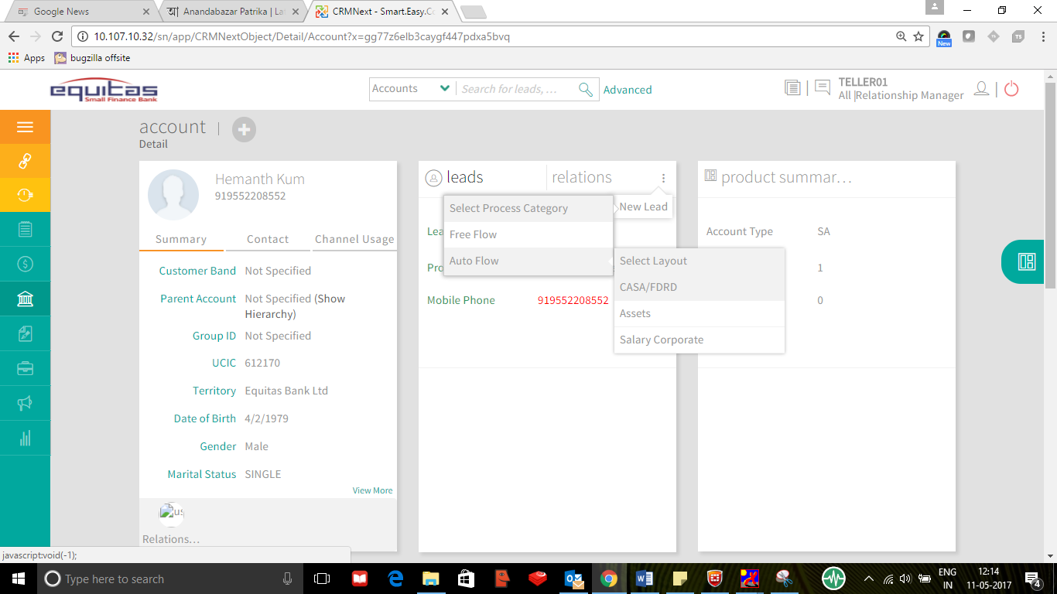
11. Field Description: The field will be further divided into 2 kinds of categories
    * 1. *Auto-populated fields:* Below table shows the fields that will be auto populated on the Lead new edit screen for ETB:

|  |  |  |  |  |  |  |  |  |  |
| --- | --- | --- | --- | --- | --- | --- | --- | --- | --- |
| Sr. No. | Field | Field Type | Field length | Field Validation | Editable | Lookup | Dependent on | Mandatory | Auto Populate |
|  | Salutation | Picker | NA | Values as: 1. Mr. 2. Mrs. 3. Ms. 4. Mstr. 5. Dr. 6. Eng. 7. Hon. 8. Prof. | No | Yes | No | Yes | Yes |
|  | First Name | Alphabet | 40 | Only text values. No special characters except for Apostrophe and "-" | No | No | No | Yes | Yes |
|  | Middle Name | Alphabet | 40 | Only text values. No special characters except for Apostrophe and "-" | No | No | No | No | Yes |
|  | Last Name | Alphabet | 40 | Only text values. No special characters except for Apostrophe | No | No | No | Yes | Yes |
|  | Preferred Mode Of Contact | Picker | NA | Values as: 1. Email 2. Phone | Yes | Yes | No | Yes | No |
|  | Primary Contact Number | Number | 20 | Only Number with one special character as "+" | No | No | No | Conditional on Preferred Mode of Contact | Yes |
|  | Secondary Contact Number | Number | 20 | Only Number with one special character as "+" | No | No | No | No | Yes |
|  | Email | Email | 30 | Text values. Special characters and numbers allowed | No | No | No | Conditional on Preferred Mode of Contact | Yes |
|  | Segment | Picker | NA | 1. Personal Banking 2. Premium Banking 3. Business Banking | No | No | No | Yes | Yes |
|  | Product Category | Picker | NA | NA | Yes | No | No | Yes | No |
|  | Product | Picker | NA | NA | Yes | No | No | Yes | No |
|  | Lead Rating | Picker | NA | NA | Yes | No | No | No | No |
|  | Lead Source | Picker | NA | NA | Yes | No | No | Yes | No |
|  | Referrals | Picker | NA | 1. Client calls 2. Client Physical visits 3. RM own prospecting 4. Referrals from CIB 5. Referrals from BB 6. Referral from PB 7. Referrals from Customer 8. Referrals from Call Centre 9. Referrals from Asset Finance 10. Referrals from Bancassurance 11. Referrals from Marketing 12. Analytics 13. Inactive Accounts – Dormant  14. Others | Yes | Yes | No | Conditional | No |
|  | Date Of Birth | Date | NA | NA | No | No | No | No | Yes |
|  | Branch | Picker | NA | NA | Yes | Yes | No | No | Yes |
|  | Nationality | Picker | NA | Kenyan, Others | No | Yes | No | Yes | Yes |
|  | National ID | Alphanumeric | 40 | Numbers with text Only | No | No | No | Conditional | Yes |
|  | Passport No | Alphanumeric | 40 | Numbers with text Only | No | No | No | Conditional | Yes |
|  | Alien Certificate | Alphanumeric | 40 | Numbers with text Only | Yes | No | No | Conditional | Yes |
|  | Assign To | Picker | NA | NA | No | Yes | No | Yes | Yes |
|  | Cust ID | Alphanumeric | 40 | Text with Numbers | No | No | No | No | Yes |
|  | Lead Originator | Picker | NA | NA | No | Yes | No | No | Yes |
|  | Campaign Name | Picker | NA | NA | Yes | Yes | Lead Source | No | No |
|  | Address | Alphanumeric | 1024 | Text values. No Special characters. Numbers allowed | No | No | No | No | Yes |
|  | City | Alphabet | 60 | NA | No | Yes | No | No | Yes |
|  | State | Alphabet | 60 | NA | No | Yes | No | No | Yes |
|  | Locality | Alphabet | 60 | NA | No | Yes | No | No | Yes |
|  | Postal Code | Number | 20 | If Core Banking has a mapping for address details then will be maintained in CRM | No | Yes | No | No | Yes |
|  | Country | Alphabet | 40 | NA | No | Yes | No | No | Yes |
|  | Comments | Alphanumeric | 1024 | Text with Numbers | Yes | Yes | No | No | No |
|  | Appointment Date Time | DateTime | NA | NA | Yes | No | No | Conditional on status Code = Appointment Fixed | No |
|  | Venue Of meeting | Alphanumeric | 60 | Text values with Number values will be accepted | Yes | Yes | No | Conditional on status Code = Appointment Fixed | No |
|  | Document Type 1 | Picker | NA | Values as: 1. Identification 2. Utility Bill 3. Income 4. Business Entity | Yes | Yes | No | Conditional on status Code = Documents Collected | No |
|  | Document Type 2 | Picker | NA | Values as: 1. Identification 2. Utility Bill 3. Income 4. Business Entity | Yes | Yes | No | Conditional on status Code = Documents Collected | No |
|  | Attachment 1 | Document | NA | NA | Yes | No | No | Conditional on status Code = Documents Collected | No |
|  | Attachment 2 | Document | NA | NA | Yes | No | No | Conditional on status Code = Documents Collected | No |
|  | Lead ID | Number | 40 | Numbers Only | No | No | No | No | Yes |
|  | Status Code | Picker | NA | NA | No | Yes | No | Yes | Yes |
|  | Lead Created On | Date Time | NA | NA | No | No | No | Yes | Yes |
|  | Account Number | Number | 40 | Numbers Only | No | No | No | No | Yes |
|  | Sent for Processing Comment | Alphanumeric | 1024 | Text with Numbers | Yes | No | Lead Status Code = send for processing | Conditional | No |
|  | Gender | Picklist | NA | Values as: 1. Male 2. Female | No | Yes | No | No | Yes |
|  | Marital Status | Picklist | NA | Value as: Married Divorced Separated Widow Single Other | No | Yes | No | No | Yes |
|  | Occupation | Picklist | NA | 1. Accountants  2. Bankers 3. Lawyers 4. Doctors 5. Engineers 6. Actuary 7. Pilot 8. Scientist 9. Drivers 10. Architect 11. Teacher 12. Lecturer  13. Carpenter  14. Painter 15. Mechanic  16. Chef  17. Pharmacists  18. Cook  19. Farmer  20. Counsellor | Yes | Yes | No | No | No |
|  | Company Name | Alphanumeric | 40 | Text with Numbers | Yes | Yes | No | No | No |
|  | Designation | Alphabet | 40 | Text values | Yes | Yes | No | No | No |
|  | Monthly Income | Number | 60 | Numeric | Yes | Yes | No | No | No |
|  | Closure Date | Date | NA | NA | No | No | No | No | Yes |
|  | Expected Closure Date | Date | NA | NA | Yes | No | No | Yes | No |
|  | Sector | Picker | NA | 1. Government  2. Telecommunication  3. Legal services 4. Construction  5. Food processing  6. Consulting  7. Retails sales  8. Franchising  9. Education  10. Pharmaceuticals 11. Hospitality & Tourism  12. Mass Media  13. Public Health  14. Information Technology  15. Waste disposal  16. Banking  17. Insurance  18. Financial services  19. FMCGs | No | Yes | No | No | Yes |

Note Box:

All auto populated fields will be modified by the user. Any changes done on lead would not update the customer details. Customer details would only be modified by the incremental job.

* + 1. *Manually entered fields:* Refer section Process Setup “Fields for Lead management” for further details

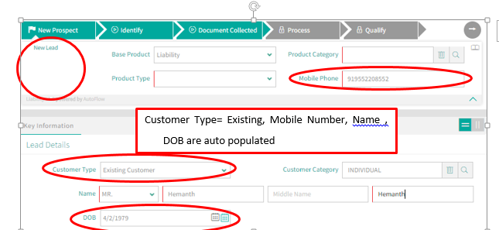

* + 1. **Sample Lead Creation Pages:**

1. **Lead Creation:**

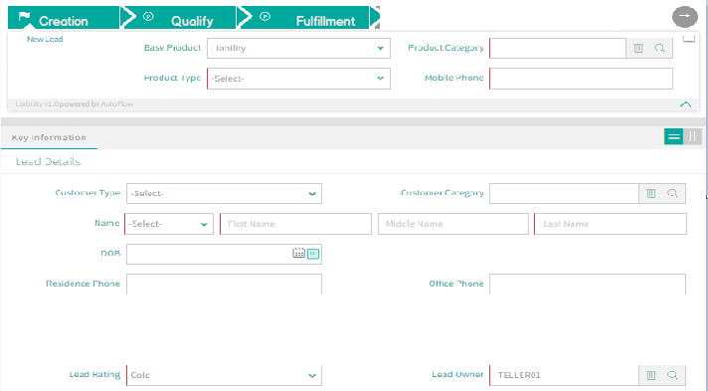

Figure 17 - Lead creation page

1. **Mandatory Fields**

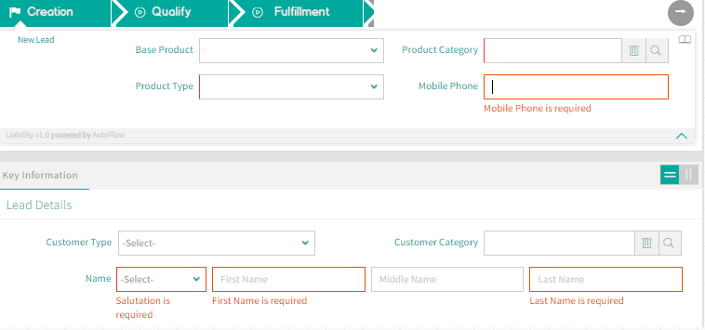

Figure 18 - Mandatory Fields

Note Box:

Fields marked in red are Mandatory fields. There will be a few more fields which will be made mandatory. These are sample screen and will change as per I&M Bank’s requirement. Refer the Fields for Lead Management for details.

.

1. **Save/Cancel Lead:**

There are 3 options available for lead processing after the data entry is done.

* + - Save: Lead saved in the same status
    - Save and proceed: Lead will be saved and moved to the next status
    - Cancel: Lead data entry is not saved and user is redirected to Lead home page



Figure 19 - Save Lead

1. **Lead View (Sample Card View)**

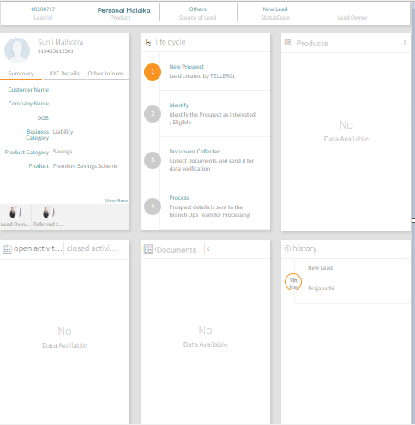

Figure 20 - Lead View

1. **Milestone description**

All the available milestones/next possible status code(s) for that user appears in GREEN. Rest remain Locked.

* + - 1. **Actionable:** After the new lead is saved, actionable will be proposed by the system.
      2. **Next possible actions:** they are proposed by clicking in the right arrow button.
      3. **Color code of milestones:** 
         1. **COMPLETED** (Stage completely traversed by the Lead)
         2. **CURRENT STAGE** (The current stage of the Lead)
         3. **NEXT POSSIBLE STAGE** (The Next possible stage which the Lead can traverse)
         4. **LOCKED** (The Stage which cannot be traversed currently by the Lead)

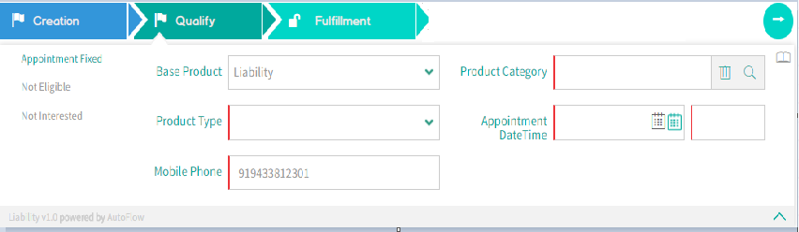

Figure 21 - Lead Stage actionable

### Lead to lead De-dupe

* + 1. Introduction: Lead de-dupe is a functionality to find the duplicate lead records based on certain pre-defined conditions at the time of lead creation. This is mainly used to prevent duplicate lead creation for the same product. In CRMNEXT, processing or rejecting the lead will be done based on de-dupe conditions and lead source. In Lead to Lead De-dupe, a user can find if duplicate leads of same product already exist in the system and then take further action. What if this is for multiple products like deposits, asset finance and term loans?
    2. **Lead to Lead Dedupe Methodologies**

1. Conditions:
   1. **Stage**: The de-dupe will be fired at below stage
      * New
   2. **Products:** Leads for same Product application would come into dedupe criteria
   3. **Other conditions applicable:**
      * This rule will only consider open leads and rejected leads stored in CRMNEXT.
      * The leads which are converted into Customer would not be considered in Dedupe rule.
2. Field Combinations**:** Either of the condition must be true

| **Sr.No** | **Rule Name** | **Duplicate record Criteria** | | |
| --- | --- | --- | --- | --- |
| **Parameter** | **Criteria** | **Result(only in case of user needs to take action)** |
|  | Mobile dedupe | Mobile Number and product | Same as on existing lead | Lead Dedupe screen will appear |
|  | Passport dedupe | Passport Number and Product | Same as on existing lead | Lead Dedupe screen will appear |
|  | Name and DOB dedupe | Name,  Date of Birth and Product | Same as on existing lead | Lead Dedupe screen will appear |
|  | Name and Mobile dedupe | Name, Mobile and Product | Same as on existing lead | Lead Dedupe screen will appear |

Table 7 - Lead to Lead Dedupe

1. **Result**: Typically, the output of de-dupe is set in the system based on the source and business conditions for further processing. There are two options that will be taken when duplicate lead is found through Lead to Lead de-dupe:
   1. Option 1**:** System enforced decision: System will not allow the duplicate lead to be saved.
   2. Option2**:** User decision on Dedupe result; User will manually take decision when duplicate lead is found. Here user have three options:
2. Ignore & Create Lead

* On click of ‘Ignore & Create Lead’, Lead will be created with Duplicate Flag as ‘Yes’ & will follow the further process (assignment process).

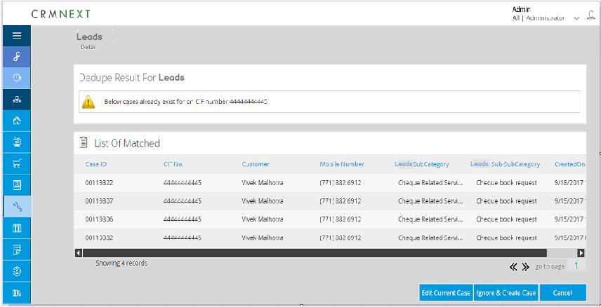

Figure 22 - De-duplication screen-Ignore & Create screen

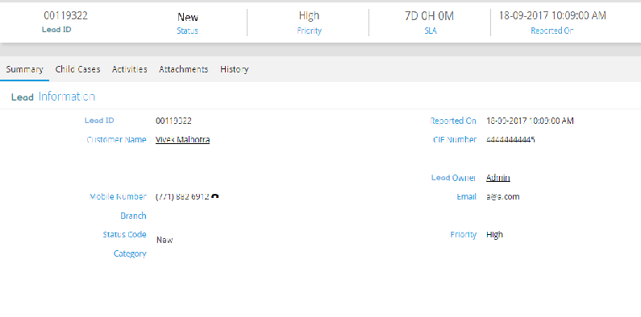

Figure 23 - Lead Detail screen- Post Ignore & Create screen

1. Edit Current Lead-

* On click of ‘Edit Current Lead’, will be redirected to the ‘New/Edit’ page of the same Lead for editing.



Figure 24 - De-duplication screen- Edit current Lead screen



Figure 25 - New/Edit Lead screen

1. Cancel

* On click of ‘Cancel’, Creation page will be closed & will be redirected to Lead Home Page.



Figure 26 - De-duplication screen- Cancel Lead screen

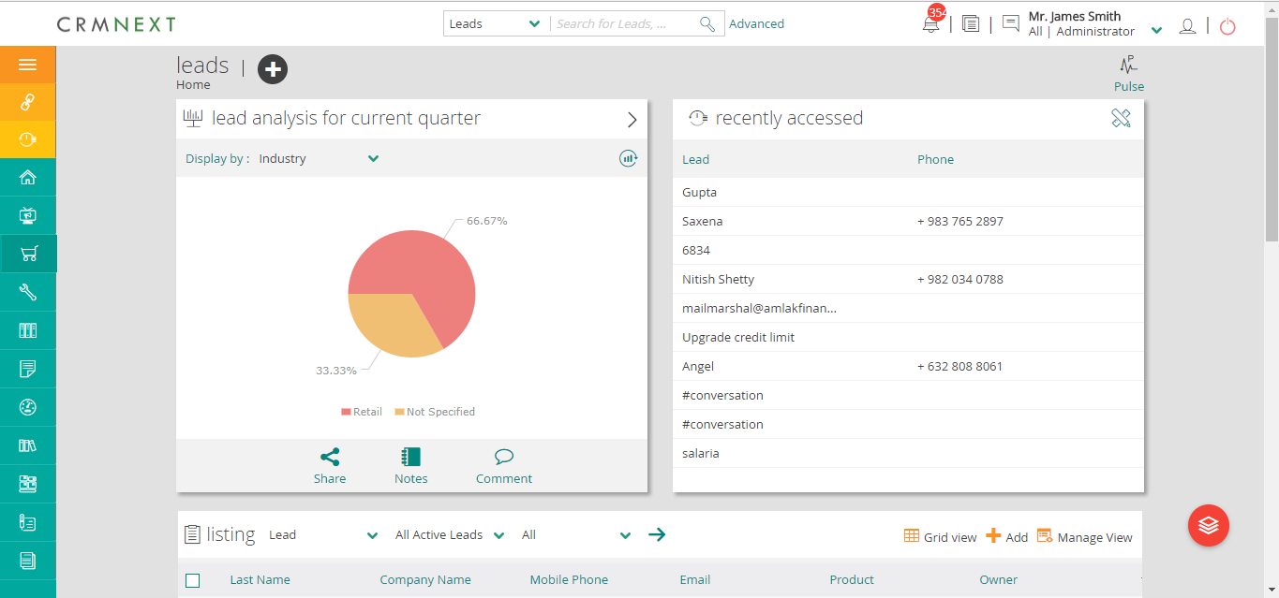

Figure 27 - Lead Home Page

| **Sr. No.** | **Start**  **Condition** | **Action** | **Action Type** | **Process** | **End Result** |
| --- | --- | --- | --- | --- | --- |
| 1 | ‘Ignore & Create’ Clicked | Lead Create | Automatic | Lead will be created with the duplicate Product. | Lead is created with ‘Is Duplicate=Yes’ |
| 2 | ‘Edit Current Lead’ Clicked | Lead Update | Manual | On the Creation Page user will re-enter it with different values | Will be redirected to creation page for re-entering |
| 3 | ‘Cancel’ Clicked | No | Automatic | Will be redirected to Lead Home Page | Will be redirected to Lead Home Page for new Lead creation |

Table 8 - Lead to Lead De-dupe table

1. Sources: The source wise output that will be set in the system are:
   1. **Source is UI:** In case the lead is created using CRMNEXT UI, then either of three above options will be implemented, but not all.
   2. **Source is Import:** In case the lead is created through UI import, then only Option 1 described above will apply.
   3. **Source is Web service:** In case the lead is created through web service then only Option 1 described above will apply.

|  |  |  |
| --- | --- | --- |
| **Lead Source** | **Lead de-dupe**  **Condition** | **Result** |
| UI | Same as mentioned above | Option 1: System Enforced  Option 2: Edit and proceed |
| Import | Same as mentioned above | Option 1: System Enforced |
| Web Service | Same as mentioned above | Option 1: System Enforced |

Table 9 - Lead Source & Option

The below are the events which require action when duplicate record is found.

| **Sr. No.** | **Action** | **If De-Dupe Positive, then Event** | **Action Type** | **Output** |
| --- | --- | --- | --- | --- |
|  | Manual Lead creation | Create lead | The lead will be saved | Lead will be updated as rejected, marked as duplicate lead. |
|  | Automatic Lead Creation | Import | NO UI available. | Lead will not be saved. |
|  | Web Service | NO UI available. | Lead will not be saved. |

Table 10 - Lead to Lead De-dupe

Note Box:

Once the lead dedupe is done, the lead will be created in the system in the stage “New Lead” and further processing would happen.

.

* 1. Qualification

Lead Qualify covers following stages: User can update the record in one of the stage.

* + - Appointment Fixed
    - Not Interested
    - Docs Collection

The following table describes summarised stage description. The details of the same are mentioned in the below section

|  |  |  |  |
| --- | --- | --- | --- |
| **Stage** | **Roles** | **Is mandatory** | **Conditional Mandatory Fields** |
| Appointment Fixed | 1. Customer Service Officer (CSO) 2. Direct Sales Executive (DSE) 3. Call Center Executive (CCE) | No | 1.Appoinment Date  2.Appoinment Time |
| Not Interested | 1. Customer Service Officer (CSO) 2. Direct Sales Executive (DSE) 3. Call Center Executive (CCE) | No | Reason |

Table 11 - Stage Description

4. 4. 1. Appointment Fixed

This stage shall be used by the user when there is a maybe situation with the Lead or complete documents are not available to proceed to Document Collection stage. User can create Appointments in CRMNEXT for Lead to be followed up in future. This section describes process under the appointment stage.

* + 1. Update- If the CRMNEXT user feels that appointment with the customer is required to collect the document or for some other reason, can fix the appointment with the customer by updating the record as “Appointment Fixed”.

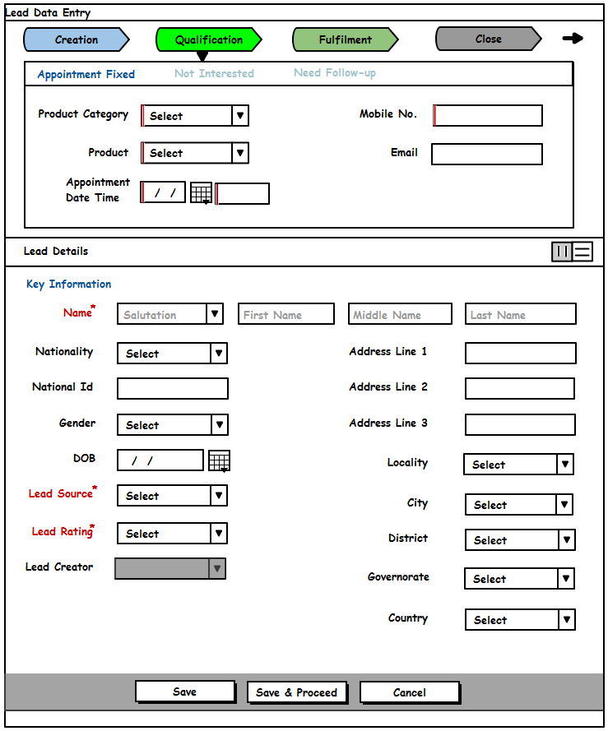

* 1. Sub Process;
     1. Appointment Creation: - An activity will be created manually by the customer to mark such appointment. Once created record will be shown on the calendar. Refer Customer 360* and Activity Management for details.

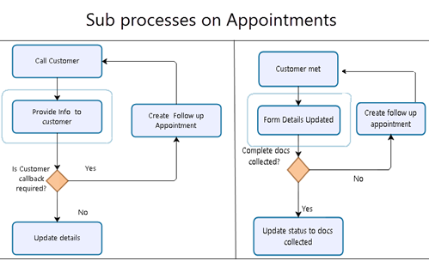

* + 1. Update: There will be 2 update on such records:
  1. Follow Up:
     1. Status Update: In case the follow up is required then appointment will be updated as “Follow UP” with follow up date and time.
     2. Record Creation: System would create Follow Up activity in case the activity record is updated as “Follow UP”. User then can update that follow up record.

Note Box:

The previous activity record will be closed.

.

* 1. Closed:
     1. Status Update: In case the customer is convinced and documents are collected, the user would update the record as “Closed”.

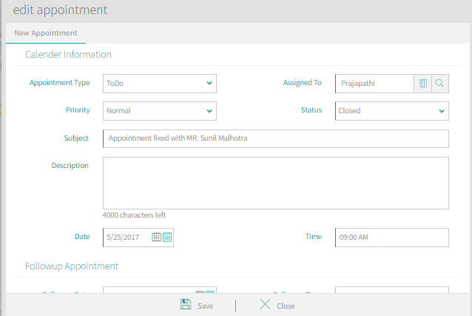

* + 1. Validation- Appointment Date and time will be mandatory for the stage.

Further Process- Based on the meeting, User can further update the record with the one of the following statuses. Details are mentioned in the below section

1. Doc Collected-Next milestone
2. Not Interested- In case customer is not interested.



Figure 28 - Appointment Fixed



Figure 29 - Lead Detail Page

* + 1. Not Interested

The provision to select the status as ‘Not Interested’ will be provided to the CSE in case

the customer decides to discontinue at any stage during the lead process.

Note Box:

The status code ‘Not Interested’ will be available to the user across all process steps as the customer can stop being interested in the product at any stage of the lead due to various reasons.

.

|  |  |  |  |  |  |
| --- | --- | --- | --- | --- | --- |
| **Sr. No.** | **Start**  **Condition** | **Action** | **Action Type** | **Process** | **End Result** |
| 1 | Not  Interested | Reject/Close Lead | Manual | The user would select the status as 'Not Interested' in case the customer wishes to discontinue with the process. Closure Remarks could also be provided. | Lead will be closed in the system and will be available in the closed view/tray of the owner. |

Table 12 - Not Interested

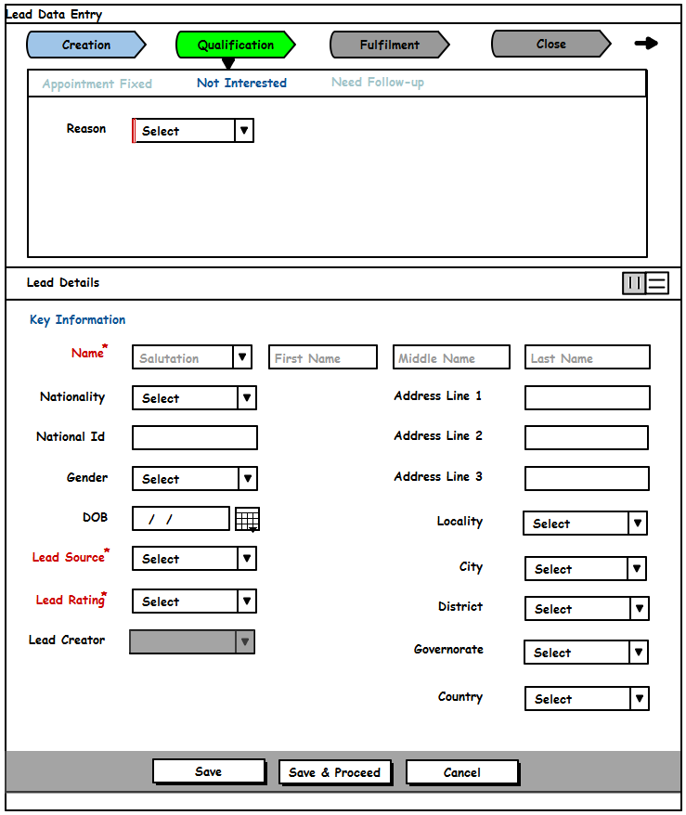

* 2. Fulfilment

Lead Fulfilment covers following stages: User can update the record in one of the stage.

* + - Not Interested
    - Docs Collection
    - Follow Up
    - Send for Processing

The following table describes summarised stage description. The details of the same are mentioned in the below section

|  |  |  |  |
| --- | --- | --- | --- |
| **Stage** | **Roles** | **Is mandatory** | **Conditional Mandatory Fields** |
| Doc Collected | 1. Customer Service Officer (CSO) | Yes | 1. Doc Type  2. Doc Sub Type  Checklist to be provided. |
| Not Interested | 1. Customer Service Officer (CSO) 2. Direct Sales Executive (DSE) | No | Reason |
| Follow Up | 1. Customer Service Officer (CSO) 2. Direct Sales Executive (DSE) | No | 1.Follow up Date  2.Follow up Time |
| Send for Processing | 1. Customer Service Officer (CSO) | Yes(condition:- Only if the record has come for rework) | Comment |



### Documents Collection

This is a stage where, customer provides the required Documents / information. This stage means that there is an approval provided by the customer for account opening.

* + 1. Doc Collection

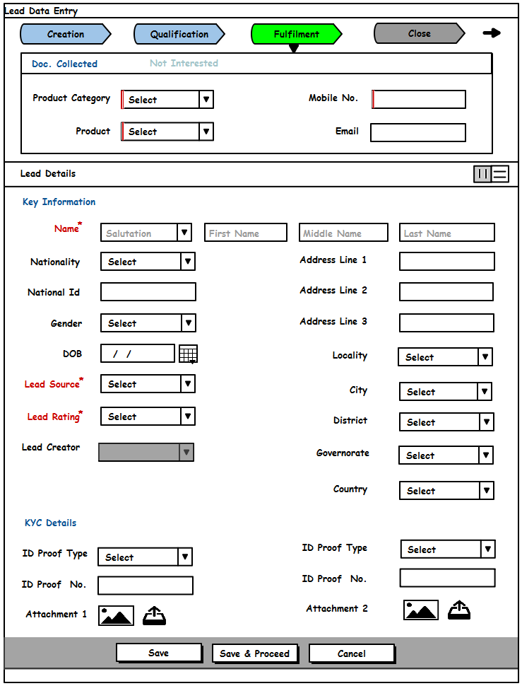

*Exhibit 15: Docs Collected Screen*

* + 1. Condition – Customer has provided all the required documents.
    2. Process- The following process will be followed for the document collection.
  1. *Physical Collection*: User will be physically collect the document from the customer. This will be done outside the system
  2. *Attach*- User will navigate to the Attachment Tab of Lead, to attach the supporting documents by inputting the respective Document Type/ Sub-Type.

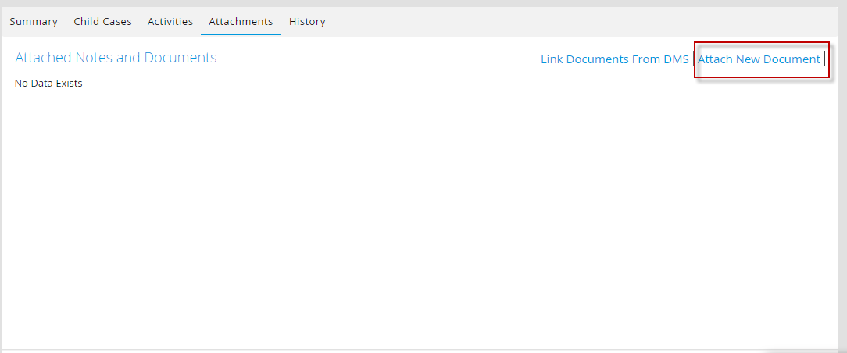

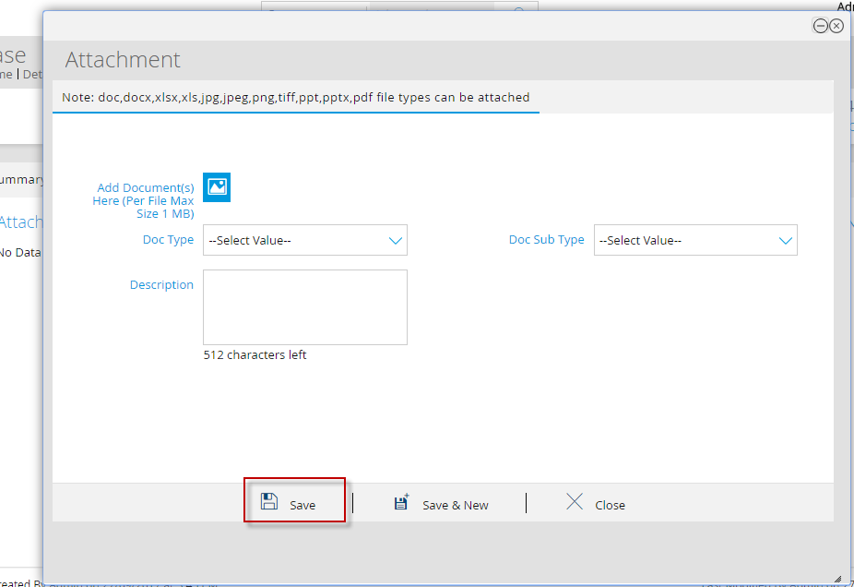

* + 1. Fields & Validation- Refer the Fields for Lead management for more details.

1. Screen and display :-

If there are missing inputs or wrong value specified validation alert allows the user to rectify and save the lead with correct data.

**A few examples of Conditional Mandatory:**

There may be fields that may be populated and become mandatory on certain other input parameters. E.g. the Others Source of Lead will only be populated only when the Source of Lead dropdown is selected as Others.

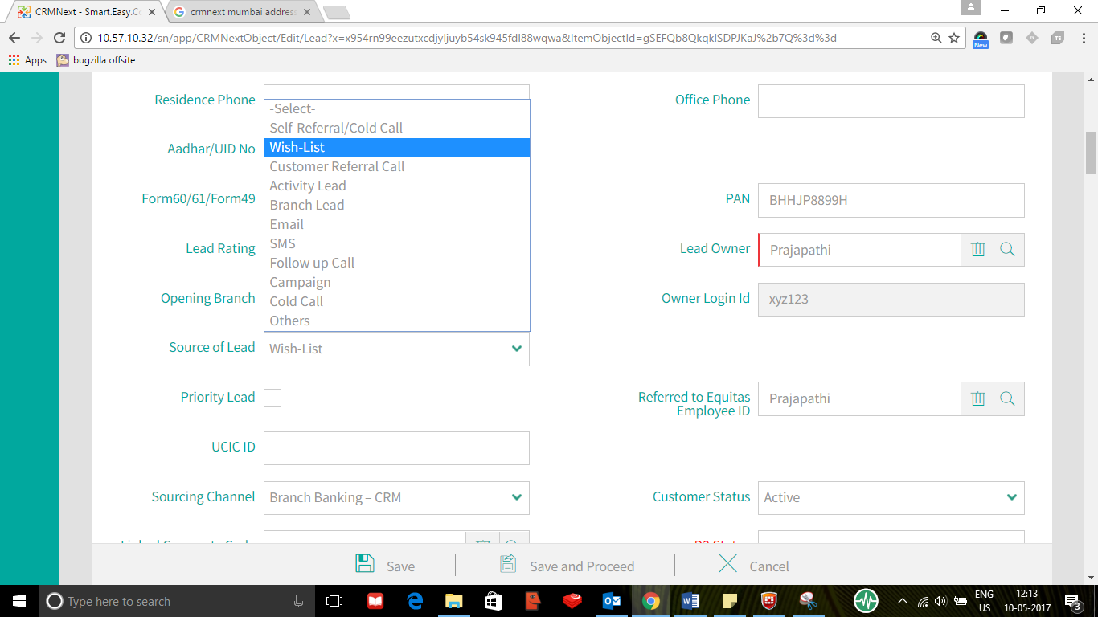

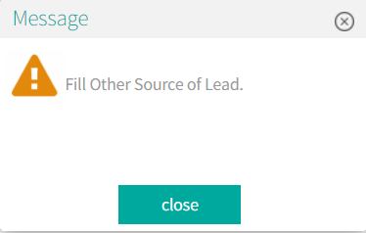

1. Further Process- The record will then be send to Finacle (Core Banking I&M System for further processing.

Lead Detail (Card View) Page on save after document collection stage

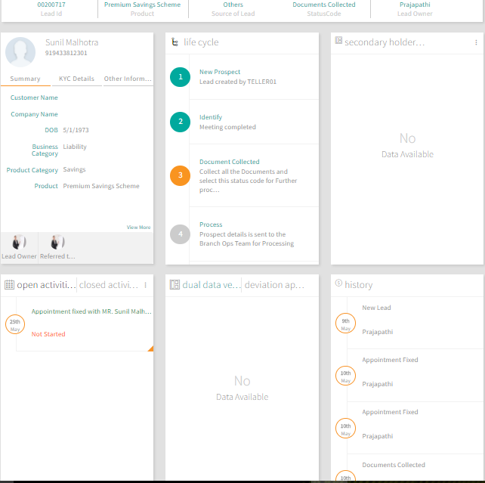

| **Sr. No.** | **Start**  **Condition** | **Action** | **Action Type** | **Process** | **End Result** |
| --- | --- | --- | --- | --- | --- |
| 1 | Customer has  carried complete  set of documents | Update Status  to Docs  Collected | Manual | Change the status code to  Docs Collected.  At this stage the detail data  entry fields will be  displayed which CSE would  fill and assign the lead to  BM for confirmation. | Lead details filled  and lead moved to Finacle (Core Banking I&M) for further process |

Table 13 - Docs Collected

### Follow UP

This stage shall be used by the user when there is a maybe situation and record has been passed on for Follow up for document or any relevant information from the Customer. User can create Appointments in CRMNEXT for Lead to be followed up for getting the required information. This section describes process under the follow up stage.

* + 1. Follow Up
    2. Update- If the user feels that follow up with the customer is required to collect the document or for some other reason, can fix the follow up appointment with the customer by updating the record as “Follow Up”.

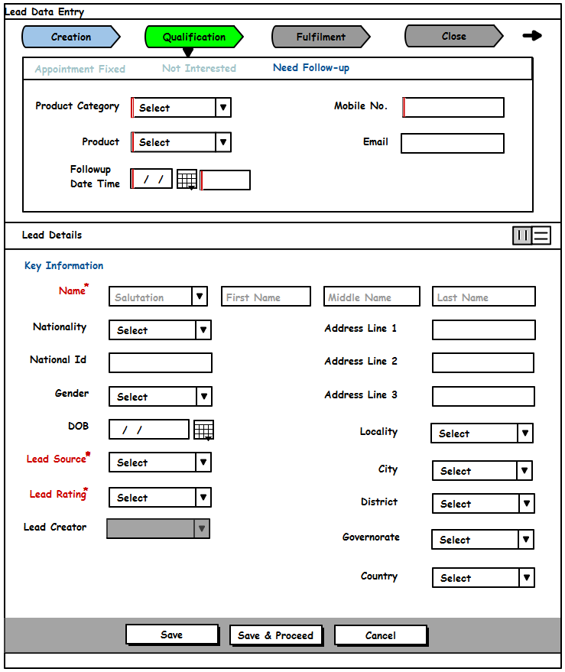

* + 1. Sub Process:
    2. Activity Creation: - An activity will be created manually by the customer to mark such follow up. Once created record will be shown on the calendar. Refer Customer 360* and Activity Management for details.



* + 1. Update: There will be 2 update on such records:
    2. Follow Up:
    3. Status Update: In case the follow up is required then appointment will be updated as “Follow UP” with follow up date and time.
    4. Record Creation: System would create Follow Up activity in case the activity record is updated as “Follow UP”. User then can update that follow up record.

Note Box:

The previous activity record will be closed.

.

* + 1. Closed:

1. Status Update: In case the customer is convinced and documents are collected, the user would update the record as “Closed”.



Figure 30 - Edit Appointment

1. Validation- Follow up Date and time will be mandatory for the stage.
2. Further Process- Based on the meeting, User can further update the record with the one of the following statuses. Details are mentioned in the below section
   1. Send for Processing- for further processing
   2. Not Interested- In case customer is not interested.

### Send for Processing (Conditional Mandatory):

This stage is provided to resend the lead record to Finacle (CBS) system so that further processing will be done.

1. Send for Processing
2. Condition – This status would generally updated on the following condition
3. Previous Status in Follow Up.
4. All the required work has been done and relevant document has been collected (if required)
5. Update- User would update the record as “Send for Processing”.
6. Validation- Cured Comments will be mandatory at this stage.
7. Further Processing- The record will then be sent to Finacle (Core Banking I&M) System for further processing.
8. Lead Processing- in Finacle (Core Banking I&M) System:

Figure 31 - Lead Handoff to Finacle System

Lead Status Update

Lead handoff for further processing

CRMNEXT

Finacle/LOS/Cards

1. Once the processing in CRMNEXT is completed, lead is handed off for fulfillment to Finacle (Core Banking I&M), LOS and Card System.
2. As the status of lead advances in the fulfilling system; the status is updated in CRMNEXT. (This update will be through a web service call from the fulfilling system to CRMNEXT or through periodic batch processing. I&M Bank to confirm on the approach)

### Lead Conversion

Figure 32 - Lead Convert

1. Lead Status update
2. Customer Creation
3. Account Creation

Core/Finacle System

CRM

If the lead is converted successfully then the status is updated in CRMNEXT as ‘Lead Converted. (Update can either be through a web service call or batch integration. I&M Bank to confirm on the approach to be taken. The details of the same will be shared in work unit document).

This status would flow in the system from Finacle (Core Banking I&M) as reverse status.

1. Lead Converted
2. Condition – The record will be updated in CRMNEXT as reverse status from Finacle (Core Banking I&M) system in case of following condition
3. Lead converted successfully (like account created successfully)
4. Update- As described above it will be updated as reverse status from Finacle (Core Banking I&M). The integration methodology will be shared in separate work unit document.
5. Validation- The following needs to be provided as part of reverse status.

### Lead Reject

Figure 33 - Lead Reject

Lead Status update

Core/Finacle/LOS

CRM

If the lead is rejected; the status is updated in CRMNEXT by Finacle (Core Banking I&M), LOS and Card system as ‘Rejected’ with reason and the lead is closed.

This status would flow in the system from Finacle (Core Banking I&M) as reverse status.

1. Lead Rejected
2. Condition – The record will be updated in CRMNEXT as reverse status from Finacle (Core Banking I&M) system in case of following condition
3. Lead Rejected due to various reason
4. Update- As described above it will be updated as reverse status from Finacle (Core Banking I&M). The integration methodology will be shared in separate work unit document.
5. Validation- The reason needs to be provided as part of reverse status.
6. Lead Sourcing

Lead sourcing and assignment within channels is explained by the illustration below:

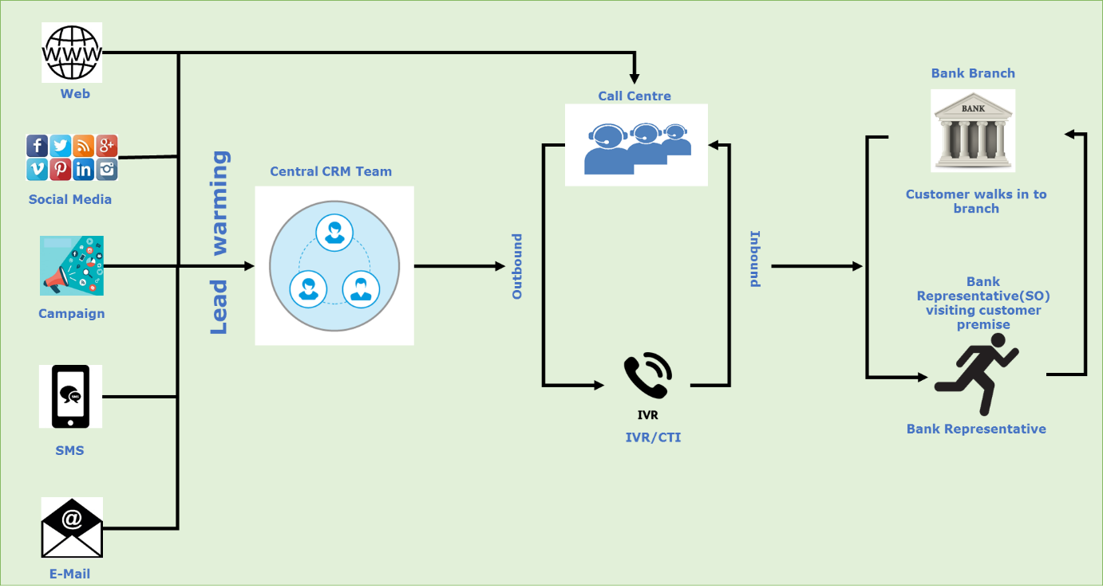

Figure 34 - Lead Sourcing

2. 1. Website

Leads will be captured in CRMNEXT from I&M BANK corporate website

* + 1. Website Data Capture Fields

Below are some sample fields that are expected to get captured from the Website and passed to CRMNEXT for lead creation.

|  |  |  |  |  |
| --- | --- | --- | --- | --- |
| **Sr. No.** | **Field Name** | **External** | **Type (internal to CRMNEXT)** | **Comments** |
|  | Name | Text | Text | Needs to be entered by the Customer |
|  | DOB | Date | Date | Mandatory. Needs to be entered by the Customer |
|  | Lead Rating | N/A | System | Default value to be set as per the requirement |
|  | Email | Text | Email | Needs to be entered by the Customer |
|  | Phone/Mobile Number | Text | Text | Needs to be entered by the Customer |
|  | Product Type | Dropdown | System | Needs to be entered by the Customer |
|  | Branch | Dropdown | System | Needs to be entered by the Customer |
|  | Status Code | N/A | System | Default |
|  | Comments | Text | Comment | Needs to be entered by the Customer |

Table 14 - Expected Data Capture Fields

* + 1. **Website Lead Creation**
  1. **Lead Capturing:** A web form such as “Contact Us” available on a company’s website will be used to capture basic details of the Customer. Once the Customer saves the details on web form, the data is sent to CRMNEXT through following modes of integration:

| **Sr. No.** | **Method** | **Type** | **Comments** |
| --- | --- | --- | --- |
| 1 | Integration Service (CRMNEXT web service) | Real time | Data needs to be pushed to CRMNEXT system using CRMNEXT web service. |
| 2 | Batch jobs | Not real time | Data needs to be put in the landing table and batch job will run and pick data. |
| 3 | CSV (Lead Import) | Not real time | User needs to upload the lead into CRMNEXT using UI import functionality |

Table 15 - Modes of Integration

Note Box:

One of the above options will be implemented for the lead capture process. I&M bank to confirm the method.

* + 1. **Processing in CRMNEXT:**

The processing in CRMNEXT starts after the lead creation in CRMNEXT.

Such leads shall have assigned to outbound Call Centre team based on the business requirement and team’s availability.

* + 1. **Assignment logic**: Based on the below condition, leads Shall be assigned to the outbound Call center
    2. **Condition:**
       1. Status Code = New Lead
       2. Channel = Website
    3. **Assigned to**: Lead will be assigned to the Call Center where that team will further assign it to the respective department manually.
       1. **Assignment to CSO**: It will be assigned to the CSO. Once it is assigned to CSO, (S) He manually assign these leads to the individual user.
       2. **Auto Assignment to Branch**: A Lead with Branch tagged shall be first assigned to CRM central team and will be assigned to BM basis the branch selected by Customer (after a fixed interval of time), the BM can then manually allocate a CSO to further work on the Lead.
    4. **Lead warming:**  The lead shall be contacted by CSO. In this process, the lead will be contacted and persuaded and further data shall be collected from the customer.
       1. **Lead update: The following data will be updated on lead if:**
          1. **The lead is not contactable**

Status = Follow Up

Product related details

Demographic details

* + - * 1. **The Lead is contactable but not interested**

Status = Not Interested

Product related details

Demographic details

* + - * 1. **The Lead is contactable and interested**

Status = Appointment Fixed

Product related details

Demographic details

Note Box:

For scenarios where warming process has been done by the call centre agent, concept of lead generator (owner (e.g. call centre agent)), and lead convertor (who converts the lead) will be implemented based on the business requirement. Lead convertor would then come from Finacle (Core Banking I&M) system as part of reverse status.

* + - * 1. **Lead assignment to Branch:**  Further lead will be assigned to the branch based on the preferred Branch select by the Customer on website. The Lead shall be assigned to the PEB/PRB Customer Service Officer of the same branch.
  1. Campaign Leads

This section explains the lead capturing part of the Campaign management however, the broad details of Campaign are explained in a separate document.

* + 1. Campaign Data Capture Fields

Below are some sample fields that are expected to get captured from Campaign sources and passed to CRMNEXT for lead creation.

| **Sr. No.** | **Field Name** | **External** | **Type (internal to CRMNEXT)** | **Comments** |
| --- | --- | --- | --- | --- |
|  | Name | Text | Text | Needs to be part of CSV upload/Manual data input |
|  | Lead Rating | N/A | System | Default value to be set as per requirement |
|  | Email | Text | Email | Needs to be part of CSV upload/Manual data input |
|  | Phone/Mobile Number | Text | Text | Needs to be part of CSV upload/Manual data input |
|  | Product Type | Dropdown | System | Needs to be part of CSV upload/Manual data input |
|  | Status Code | N/A | System | Default |
|  | Campaign ID | Dropdown |  | Needs to be part of CSV upload/Manual data input.  (Here the campaign needs to be selected/passed) to tag the leads with the campaign. |
|  | Comments | Text | Comment | Needs to be part of CSV upload/Manual data input |
|  | Source | N/A | System | Default- Campaign |
|  | Campaign Sub Channels | Dropdown |  | Needs to be part of CSV upload/Manual data input.  (Here the campaign needs to be selected/passed) to tag the leads with the campaign. |

Table 16 - Expected data capture fields

* + 1. **Campaign Lead Capturing & Processing**

There will be various types of campaigns like

* 1. Offline
  2. Digital
  3. Email
  4. Generic

Leads collected under such events need to be captured in CRMNEXT in detail

for further processing. Leads will be captured in CRMNEXT through following ways:

1. Manual creation through UI
2. Lead import through UI
3. Lead import through batch job

Note Box:

Campaign code is required to be captured on the leads to know the performance of the campaign. Refer the Campaign document for further details.

One or all methods will be used to capture the campaign related leads in CRMNEXT. All the above methods are described in the below sections:

* + 1. **Manual Creation through UI**

1. Data Capturing: The Sales user will login and capture the relevant data in CRMNEXT together with the Campaign Code. Refer section above for more details
2. **Processing in CRMNEXT**: It will be processed as described in the branch walk in process. (Refer section above for more details)
   * 1. **Lead Import through UI**
3. **Data Capturing**: The central uploader/business user will login and will import the lead data in CRMNEXT using the import action button.

Note Box:

* + - *Data should be provided in the specified CSV format provided by CRMNEXT.*
    - *One needs to be careful about the volume of data getting imported through UI, it should not be more than 5000.*
    - *Sourced by shall be captured in CSV during import, which shall reflect at lead level*

1. **Processing in CRMNEXT:** It will be processed as described in the website leads. (Refer section “Website” Point 2)
   * 1. **Lead Import through batch job**
2. **Data Capturing**:
   * 1. The central uploader/business user will create the file and put it in FTP location.
     2. A scheduled Batch Job will run, pick those data from the file at the specified location and import the data in CRMNEXT.

Note Box:

*Data should be provided in the specified format provided by CRMNEXT.*

1. **Processing in CRMNEXT**: It will be processed as described in the website leads. (Refer section “Website” Point 2)
   1. Referrals

Referrals will become one more source of generating Leads, where the existing customers (Both Managed and Non-managed) can refer their acquaintances for subscribing products from I&M Bank. Lead source of all those Leads are stamped as “Referrals”. There will be below scenarios for referrals:

* 1. Existing Customer interested in a different Product:
     1. In case of a managed Customer, the RM of the Customer becomes the Owner of the Lead and processes it as per respective process flow of the product being selected
     2. In case of a non-managed Customer, the Lead owner will be decided as per the assignment logic specified for the organization for Lead assignment.**(This will be removed from here as this is covered in multiple lead capture section)**
  2. Existing Customer referring others:
     1. In case of an existing Customer referring another existing managed Customer for a product, the RM of the referred managed Customer becomes the owner of the Lead.
     2. In case of an existing Customer referring another existing Customer/New to Bank Customer, the Lead owner will be decided as per the assignment logic specified for the organization for Lead assignment.
     3. In case of an existing managed Customer referring another existing Customer/New to Bank Customer for a product, the RM of the referring managed Customer becomes the owner of the Lead.
     4. In case of an existing managed Customer referring another existing managed Customer for a product, the RM of the referred managed Customer becomes the owner of the Lead.

|  |  |  |  |  |
| --- | --- | --- | --- | --- |
|  |  | **Referred** | | |
| Referring |  | Existing Non Managed Customer | Existing Managed Customer1 | New to Bank Customer |
| Existing Non Managed Customer | Lead Owner=As per assignment logic | Lead Owner=RM of Existing Managed Customer1 | Lead Owner=As per assignment logic |
| Existing Managed Customer2 | Lead Owner=RM of Existing Managed Customer2 | Lead Owner=RM of Existing Managed Customer1 | Lead Owner=RM of Existing Managed Customer2 |

* + 1. Referral Lead capture
    2. During lead sourcing through Branch Walk-in/Direct Sales: The idea is to facilitate the user for creation of additional leads, while creating lead for an already walked in/contacted Customer. If the already contacted/walked in customer wants to refer another customer, a section on the lead screen itself will be created, which will capture the referred customer’s name, products to be pitched, contact details etc. On saving of the same, multiple leads with each product being selected will be created in CRMNEXT and the process specific to those products will kick-in. There will be provision in CRMNEXT, where the user will specify, whether the referred customer is an existing customer or new to Bank.

1. If existing, then the user will be required to specify the existing customer’s name and other details as mentioned in section (1) above.
2. If new to bank, then the user would mention the customer’s name and other details as specified in section (1) above.
   * 1. When a Customer calls in contact center: The idea here is to make a provision for service to sales conversion in I&M Bank. When a Customer calls in the contact center and the service is completed, the agent can ask for referral from the customer. Upon getting a positive response, agent can capture the referred Lead’s name, contact details and products to be referred in a referral screen designed in CRMNEXT (refer multi product pitch section).
     2. When an outbound call is made to a Lead/Customer: When an outbound call is made to a Lead/Customer, referrals will be captured in CRMNEXT, either in the same Lead screen (as mentioned in section (1) above).
     3. Referral Lead processing

Once the referrals are captured in CRMNEXT, based on the various scenarios explained in section, the processing of the Lead can initiate. Below is the scenario wise Lead processing steps:

* + 1. Existing Customer referring existing managed Customer:

1. While the Lead for such Customer is created by any of the Lead capture methods explained above, the RM of the managed Customer, becomes the owner of the Lead and an alert to the RM (Lead Owner) is sent.
2. The RM then can start processing those Leads as per the product wise process defined.
   * 1. Existing Customer referring another existing Customer/ New to Bank Customer:
3. While the Lead for such Customer is created by any of the Lead capture methods explained above, the Lead owner is decided as per the assignment logic devised for the organization (Please refer Lead assignment section, which is for such Leads, the Lead owner will be decided in a round robin manner from the RMs from the Branch(s) where the lead city is matched with the respective servicing Branch)
4. The Lead owner can then start processing the Lead as per the product wise process defined.
   * 1. Existing managed Customer referring another existing Customer/New to Bank Customer
5. While the Lead for such Customer is created by any of the Lead capture methods explained above, the RM of the managed Customer, becomes the owner of the Lead and an alert to the RM (Lead Owner) is sent.
6. The RM then can start processing those Leads as per the product wise process defined.
   * 1. Existing managed Customer referring another existing managed Customer:
7. While the Lead for such Customer is created by any of the Lead capture methods explained above, the RM of the referred managed Customer, becomes the owner of the Lead and an alert to the RM (Lead Owner) is sent.
8. The RM then can start processing those Leads as per the product wise process defined.

1. Process Setup

This section details the details about the process design in CRMNEXT.

1. 1. Status Codes

The status codes that will be available on lead for the user are as follows:

|  |  |  |  |  |
| --- | --- | --- | --- | --- |
| **Sr. No** | **Status Code** | **Milestone** | **Role** | **Action** |
| 1 | New Lead | Creation | All | New Lead creation |
| 2 | Appointment Fixed | Qualification | All | For fixing the appointment. |
| 3 | Not Interested | Close | All | In case customer is not interested |
| 4 | Docs collected | Fulfilment | 1. Customer Service Officer (CSO). | All the Documents have been collected & For Further processing in Finacle (Core Banking I&M) |
| 5 | Follow-Up | Fulfilment | 1. Customer Service Officer (CSO). | For fixing the follow up appointment. |
| 8 | Send for Processing | Fulfilment | 1. Customer Service Officer (CSO). | For Further processing in Finacle (Core Banking I&M) |
| 9 | Lead Closed | Close | All (view only) | Reverse Status from Finacle (Core Banking I&M). |
| 10 | Lead Rejected | Close | All (view only) | Reverse Status from Finacle (Core Banking I&M). |

Table 18 - Status Codes

* 1. Views

The list of views that will be available are listed in the table below:

| **Sr. No.** | **Name of the View** | **Description** | **Condition** | **Columns** | **Access To** | **Scope of View** | **Action Button** |
| --- | --- | --- | --- | --- | --- | --- | --- |
|  | New Leads | This will list the new leads created in the system and will be visible to the Owner of the lead and the seniors in the hierarchy above. | Status= New Lead | Lead ID,  Lead Name,  Lead Amount,  Lead Owner,  Lead Assigned to,  Lead Created On | All | Individual | Appointment Fixed |
|  | Appointment Fixed | The leads for which the appointment has been fixed will be listed in this view for the Lead Owner and its hierarchy | Status= Appointment fixed | Lead ID,  Lead Name,  Lead Amount,  Lead Owner,  Lead Assigned to,  Lead Created On | All | None |  |
|  | Follow Up | The leads for which the follow up needs to be done will be listed in this view for the Lead Owner and its hierarchy | Status= Follow Up | Lead ID,  Lead Name,  Lead Amount,  Lead Owner,  Lead Assigned to,  Lead Created On | All | None | Send for Processing |
|  | Docs Collected | The leads currently in the stage of docs collected will be visible in this view for the Lead Owner and its hierarchy | Status= Doc Collected | Lead ID,  Lead Name,  Lead Amount,  Lead Owner,  Lead Assigned to,  Lead Created On | All | None |  |
|  | Referral Leads | All Leads referred by the user and being fulfilled by others will be visible in this view along with their current statuses | Status= New | Lead ID,  Lead Name,  Lead Amount,  Lead Owner,  Lead Assigned to,  Lead Created On | All | Individual | Appointment Fixed |
|  | Campaign Leads | All leads with the source selected as campaign will be having a view to be displayed to the sales team and the marketing team. | Status= New | Lead ID,  Lead Name,  Lead Amount,  Lead Owner,  Lead Assigned to,  Lead Created On | All | Individual | Appointment Fixed |

Table 19 - List of Views

Note Box:

The above views depend on the working buckets available in the system, hence few views will be added or removed basis the flow and the solution that will be finalized for Lead management. There is also a possibility of more number of views getting added to the list during development depending upon process fulfilment.

* 1. Alerts Matrix

The list of the alerts to be sent to CA/BM/BC/BCM analysed as per the requirement is listed in the table below:

|  |  |  |  |
| --- | --- | --- | --- |
| **Sr. No.** | **Alert** | **Trigger Conditions** | **Triggered To** |
|  | Appointment Fixed | Lead Status Code = Appointment Fixed | Lead Owner |
|
|
|  | Follow-up | Lead Status Code = Follow-up | Lead Owner |
|
|

Table 20 - List of Alerts

* 1. Customer communication

At each of the stages of lead entry, update and transfer to Lead fulfilment process, a communication in the form of an email and SMS will be sent to the customer. This will be configurable at the product and stage level. The content of such communication will be configurable by the product admin.

| **Sr. No.** | **Source** | **Event** | **Mode** | **Condition** | **Content** |
| --- | --- | --- | --- | --- | --- |
|  | Call Center | Call Centre Agent fixes appointment | SMS | Lead Status = Appointment Fixed | Thank you for your interest in <Product>.Your Appointment has been fixed (date and time). Our Bank representative will get in touch with you shortly. |
|  | Branch/Call Center | Lead Update resulting in NF | SMS | Lead Status = Need Follow Up (NF) | Dear Customer, Thanks for spending your precious time with our officer <<SA/CA>>. As required our officer will again get in touch with you at <<Time>> on <<Date>> |
|  | Branch/Call Center | Lead Update resulting in NI | SMS | Lead Status = Not Interested (NI) | Dear Customer, Thank you for your precious time. For any further queries on banking products please contact your nearest branch or Call Center. |

Table 21 - Customer Communications

Note Box:

The above templates are for illustration and understanding purpose. I&M Bank to share the actual templates to be sent along with the conditions when the communication to be sent. Email templates to be discussed, whether required or not, during the IDR sessions.

1. Assumptions
   * 1. Mappings
   1. All branches shall have PEB-CSO, PRB-CSO, PEB-DSE, PRB-BM, PEB-BM users mapped to it and the branches under an area shall have Head mapped to it.
   2. Branch to PEB-CSO, PRB-CSO, PEB-DSE, PRB-BM, PEB-BM mapping shall be made available in the system and be used for assignment of the leads.
   3. The master of branch to PEB-CSO, PRB-CSO, PEB-DSE, PRB-BM, PEB-BM mapping of an area shall be maintained by the bank post implementation.
   4. The branch to city mapping to be provided by I&M Bank and the mapping post implementation to be maintained by Bank.
      1. **Data Upload**
   5. The data upload in the system will be done only in csv/txt comma separated format.